**University of Texas Permian Basin**

**EENG 4460 Senior Design**

**Automated Multi-Dog Feeder**

Kelby Lang- Team Leader

Slaton Bird - Team Member

Brian Grahmann - Team Member

Department of Electrical Engineering

The University of Texas Permian Basin

Submitted to ---

Course Instructor

Dr. Mohsin M. Jamali

Department of Electrical Engineering, The University of Texas Permian Basin

Project Advisor

Dr. Mohsin M. Jamali

**Submitted as part of the requirement for the course:**

**EENG 4460 Senior Design**

Date of Submission

May 4th, 2023

**Executive Summary**

The proposed design is an automated dog feeder for two-dog homes. It aims to provide consumers with a hands-off product that remotely feeds animals based on a user-input schedule. It will also feed pets the appropriate amount, promoting dog health. After a short training period to get each dog to respond to their specific feeding time alerting sound, it will not be necessary for pet owners to be involved at mealtime. Refilling the two food compartments is only necessary about once a week. The product is designed in such a way that prevents food aggression incidents between the dogs and between the dogs and pet owners. In this way, the proposed design provides a fully automated solution for convenient pet feeding, health, and safety.

Before conducting the preliminary design, marketing and engineering requirements were established. This involved collecting data through market research. The marketing requirements are based on the needs of the customer and shareholder, and each engineering requirement is directly traceable back to at least one of the marketing requirements. Advanced analysis was then done to compare how the requirements correspond with each other.

The preliminary detailed design kicked off with a thorough literature review of currently available pet feeding apparatuses. It was found that, although there are many types of feeders on the market, none provide the solutions that the proposed design intends to. Based on this information, a list of design constraints was formulated, and concepts were generated. Numerous brainstormed designs, including the electrical, software, and mechanical sectors of the feeder were produced. 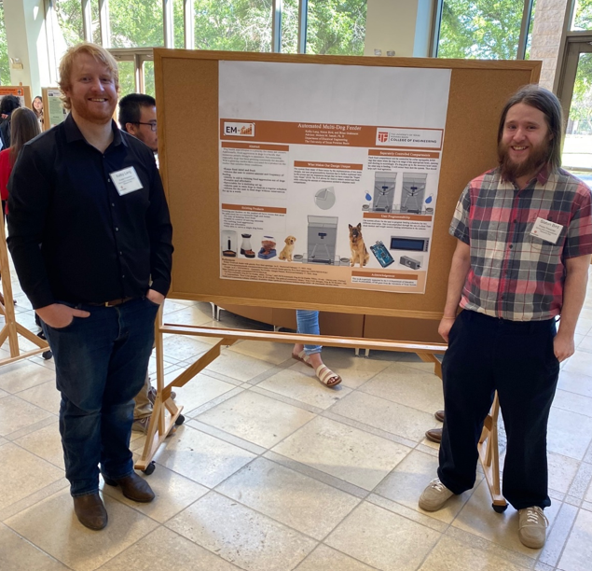Attending the University of Texas Permian Basin undergraduate research day was a great way to acquire personalized market research from dog owners. Presenting the proposed production in a public setting allowed for feedback and improvements of the model. After doing a comparison analysis of the generated concepts a finalized design was chosen. Using the collected data from the literature review, the electrical, mechanical, and controller parts were selected. The feeder dimensions were determined from the design constraints and size of the food compartments needed. 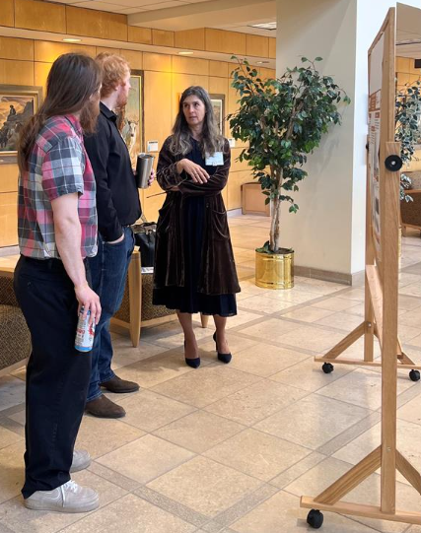Before prototyping construction, the applicable ethics and standards were analyzed for consumer pet products. Additionally, a hazard and failure analysis was conducted to ensure the design was safe. The construction of the prototype was procured from wood. Problems were encountered in assembling the structure properly with moving components. Multiple friction points were identified and ultimately removed. After making improvements to the physical design, all electrical components were mounted, and the appropriate circuity was implemented. Additionally, programming the microcontroller was done at this time. Following assembly and wiring terminations, each step in the process was tested. Refinement and improvements were made in all sectors of the design, including mechanical, electrical circuitry, and software coding. The end result is a proof of concept that operates but could be improved upon. Upon completion of the prototype, the established design constraints were revisited ensuring they were met.

The beginning stages of an upgraded production model was then designed with an enhanced mechanical design for optimal operation. Furthermore, multiple electrical components were replaced with more desirable ones with improved functionality. The production model design provides a smaller and lighter feeder with the appropriate hardware and software needed to execute system processes at optimal levels.

Designing a new product is an iterative procedure. Many improvements and alterations had to be made to provide an operable device. Social and environmental issues were explored and considered when designing the production model. Many aspects need to be considered in an electrical engineering design. The process needs to be extremely detailed. Overall, working as a team and challenging each other was the key to success in producing a viable proof of concept.

Table of Contents

**Introduction**

Objectives

**Requirements**

Marketing Requirements

Engineering Requirements

**Advanced Analysis**

Engineering-Marketing Tradeoff Matrix

Engineering Tradeoff Matrix

**Detailed Design**

Literature Review

**Design Constraints**

**Concept Generation**

Preliminary Designs

Pugh Table

Proposed Design

**Design Description**

Physical Design

Functional Decomposition

Electrical Design Elements

Software Flowcharts

**Iterative Nature of Design Changes**

SLS Design Change

Telescoping Rails Mounting Changes

DC Motor and Mounting Changes

**Cost Analysis**

Prototype Bill of Materials

Marginal Production Bill of Materials

**Ethics and standards**

**Hazards and Failure Analysis**

**Management of the project**

Responsibilities

Prototyping

Scheduling

**Progression of Prototype**

Frame

Hopper

SLS

Railings+Bowls

Wheels

Electrical

RFID

**Prototyping Testing Verification**

**Production Model Design**

**Meeting Constraints**

**Environmental and Global Issues**

**Conclusion**

Problems encountered & lessons learned

**References**

**Appendices**

Appendix A: PinOut Diagram

Appendix B: User’s Manual

Appendix C: Main Code

List of Figures

**Figure 1:** Complete House of Quality21

**Figure 2:** Kidney design Lazy Susan22

**Figure 3:** Existing gravity dog feeders24

**Figure 4:** Arf Pets Automatic Smart Feeder 24

**Figure 5:** Sketch of first design draft 29

**Figure 6:** Sketch of second design draft 30

**Figure 7:** Sketch of third design draft 31

**Figure 8:** Sketch of fourth design draft 33

**Figure 9:** Sketch of proposed design 35

**Figure 10:** Proposed physical design 36

**Figure 11:** Feeder frame and hopper 37

**Figure 12:** Servo motor, SLS, and funnels 38

**Figure 13:** Bowl, bowl holder, and weight sensor 38

**Figure 14:** Platforms, telescoping rails, motor, and wheels 39

**Figure 15:** Arduino Mega microcontroller and LCD/Button Interface 40

**Figure 16:** Dog feeder with extensions visible 40

**Figure 17:** Flow diagram for dog feeder level 0 functionality 41

**Figure 18:** Level 1 Power System functionality 42

**Figure 19:** Level 1 Measurement and Food Dispensing functionality 43

**Figure 20:** Level 1 Dog Detection + Food Supply functionality 44

**Figure 21:** Level 1 User Programmability functionality 45

**Figure 22:** Diagram of battery charging circuit 47

**Figure 23:** Diagram of motor direction controller 47

**Figure 24:** Central Loop Flowchart 48

**Figure 25:** User Interface Flowchart 49

**Figure 26:** Feeding Cycle Flowchart 51

**Figure 27:** SLS Design Change 54

**Figure 28:** Telescoping rails mounting location change 55

**Figure 29:** DC motor upgrade 56

**Figure 30:** DC motor mounting improvement 57

**Figure 31:** Gantt chart for week 1-8 66

**Figure 32:** Gantt chart for week 9-1666

**Figure 33:** Front, side, and back view of feeder frame

**Figure 34:** Progression of food hopper

**Figure 35:** Dimensions of food hopper

**Figure 36:** SLS Construction

**Figure 37:** SLS Construction

**Figure 38:** Trapezoidal cutout in SLS for ¼ cup volume

**Figure 39:** Servo motor and drive shaft

**Figure 40:** Railings and bowl platforms

**Figure 41:** Railings and bowl platforms

**Figure 42:** Mounting weight sensors

**Figure 43:** Bowl holder construction

**Figure 44:** DC motor and wheel mounting

**Figure 45:** Momentary contact switches

**Figure 46:** Funnel construction and mounting

**Figure 47:** Prototype RFID tags and sensor

**Figure 48:** Speaker current amplifier

**Figure 49:** Prototype wiring and electrical components

**Figure 50:** Front, back, left side, and right side views of completed prototype

**Figure 51:** Testing and Integration Plan

**Figure 52:** First Mechanical Unit Test

**Figure 53:** Second Mechanical Unit Test

**Figure 54:** Software Motor Unit Test

**Figure 55:** Motor Actuation Integration Test

**Figure 56:** Software Sensors Unit Test

**Figure 57:** User Interface Unit Test

**Figure 58:** Software Settings Unit Test

**Figure 59:** Functional Menu Integration Test

**Figure 60:** Operational Integration Test

**Figure 61:** Dimensions for rack and pinion and linear actuator

**Figure 62:** Top view of component layout on feeder base for production model

**Figure 63:** Top view of component and feeder base dimensions

**Figure 64:** Food hopper dimensions for production model

**Figure 65:** Food hopper volume, dimensioning, and calculations

**Figure 66:** Frame and hopper dimensions of production model

**Figure 67:** Figure and calculation of front and back walls of food hopper

**Figure 68:** Figure and calculations for side walls of food hopper

**Figure 69:** Active RFID tag & Antenna

**Figure 70:** Final design for production model

**Figure 71:** Melted wires

List of Tables

**Table 1:** System requirements for the automated dog feeding apparatus 17

**Table 2:** Engineering-marketing tradeoff matrix for the automated dog feeding apparatus 19

**Table 3:** Engineering tradeoff matrix for the automated dog feeding 20

**Table 4:** Pugh Concept Table 34

**Table 5:** Level 0 Dog Feeder Functionality 41

**Table 6:** Level 1 Power System Functionality 42

**Table 7:** Level 1 Measurement and Food Dispensing functionality 43

**Table 8:** Level 1 Dog Detection + Food Supply functionality 44

**Table 9:** Level 1 Programmability Functionality 45

**Table 10:** Prototype Bill of Materials 58

**Table 11:** Team member responsibilities 63

**Table 12:** Prototyping Schedule65

**Table 13:** Production Model Bill of Materials 103

**Introduction:**

According to the Veterinary Center of America (VCA) Animal Hospitals, approximately 25-30% of the general canine population is obese in the United States, with 40-45% of dogs aged 5-11 years old weighing in above that of healthy weight range **[1]**. Additionally, stated in the Raw Bistro Blog, food aggression is quite common in dogs. One study reported that nearly 20% of all dogs show signs of food aggression **[2]**. According to the results of a 2021 survey conducted by the American Pet Products Association, dog ownership in the United States has increased by 13% since 1988 **[3]**. Most dog feeding products on the market fail to safely feed multiple animals with different types of foods in a single device.

Many dog owners struggle to keep their animals healthy and safe during feeding time. Overfeeding canines is a problem that countless pet owners struggle with. As a result of a continually growing market, there is a strong need for a product that easily enables dog owners to feed their dogs remotely and in a healthy manner while maintaining a safe environment for both animals and humans. It would also be necessary for this product to service multi-dog homes in a safe manner.

Many prescription and specialty diet dog foods are high cost and use volatile compounds to stimulate dog appetite that evaporate when open to atmosphere. Automatic dog feeding products currently on the market either continually gravity flow all stored food from an unsealed container or blindly dispense a preset amount. Many pets eat less when their owners are not home for extended periods of time. There is a need in the market for a multi-animal automatic pet feeder that can measure how much food was eaten, what remains, and acts on that information while sealing the remaining supply to preserve freshness and conserve food.

**Objectives:**

In order to meet this need, a fully automated, self-training, dog food dispenser is to be designed that does not overfeed or underfeed animals. It will also be styled in such a way that multi-dog owners can feed each individual dog the correct serving amount and food brand to meet each individual dog’s needs. Also, this product will have a training component to alert which dog needs to eat and prevent any other animal from stealing another dog’s meal. There will be multiple feeding compartments that sense if the correct dog is there before it opens. If the wrong canine comes to the incorrect compartment, it will not open. If it is already open, it will close when the wrong dog gets too close. Weight sensors will be utilized to detect if the food has been eaten or if some remains to ensure proper feeding amounts. This will all be programmable using a local keypad and displayed on the Liquid Crystal Display (LCD) screen(s). Pet owners will not have to be present at feeding times.

**Marketing Requirements:**

1. Low cost.
2. Easily portable when food storage is empty.
3. User-friendly.
4. Should maintain a healthy diet for canines.
5. Should be safe and usable for multi-dog applications.
6. Be able to feed any size of dog for a minimum of 1 week.
7. Excellent sound quality for food-time alerting.
8. Keeps food sealed and fresh.

**Engineering Requirements:**

1. Marginal production cost should not exceed $60.
2. The dimensions should not exceed 3’x3’x2’.
3. Be able to power using a cord plug-in to a 120v, 15amp receptacle.
4. System will operate for a minimum of 28 feeding cycles in absence of power.
5. System will operate 24/7, 365 days a year given power source.
6. System should be able to operate in the temperature range of 60 degrees F to 80 degrees F.
7. Should be programmable for food proportions for dogs weighing 3-12lb, 13-20lb, 21-35lb, 36-50lb, 51-75lb, 76-100lb, and 100lb+.
8. Provide 1.8 gallons of food storage for each dog.
9. Owner should be able to select a unique sound per dog to be used for the alerting process.
10. System should alert dog(s) based on users inputted schedule.
11. Average feeding-time should not exceed a specified time, chosen by the user.
12. Compartments will open or close when dog is at 1m from apparatus.
13. Feeding amount accuracy will be within 90% with a resolution of ¼ cup.

**Engineering Requirements:** Properties

1. Marginal production cost should not exceed $60.

This requirement is verifiable because it correlates the prices with current dog feeding systems, while providing a superior product. Additionally, listing a singular cost is unambiguous because it provides a clear understanding of the product value. This price is also traceable and realistic as it serves the customer needs at a competitive market dollar figure.

1. The dimensions should not exceed 3’x3’x2’.

The required dimensioning is abstract because it states the size conditions of the apparatus. Furthermore, the proportions are verifiable as they align with the volume needed to house the required amount of dog food. Additionally, this requirement is unambiguous because it simply states the size limit. It is also traceable and realistic because it satisfies the customer needs in affordability, portability, being user-friendly, multi-dog safe, and providing adequate storage capacity.

1. Be able to power using a cord plug-in to a 120v, 15amp receptacle.

The required power source is abstract and unambiguous because it simply states how the product will be energized. Furthermore, it is verifiable and realistic because 120v, 15-amp receptacles are the most common power source in residential homes. It is also traceable because it satisfies the customer needs in affordability, portability, being user-friendly, multi-dog safety, and storage capacity.

1. System will operate for a minimum of 28 feeding cycles in absence of power.

This requirement is abstract and unambiguous because it provides a minimum number of feeding cycles and, it is a short and clear statement. Additionally, it is verifiable and realistic because this measurement meets the feeding needs of 2 dogs for 1 week. It is also traceable because it satisfies the customer needs of being user friendly.

1. System will operate 24/7, 365 days a year given power source.

The required operation specifications are abstract because it states the products capabilities and the condition of having a proper power source to fulfill them. Furthermore, the operation longevity is verifiable as it provides food for dogs year-round. Additionally, this requirement is unambiguous because it simply states the operation timeline. It is also traceable and realistic because it satisfies the customer needs in being user friendly and provides a realistic target.

1. System should be able to operate in the temperature range of 60 degrees F to 80 degrees F.

This requirement is abstract and unambiguous because it provides the numerical temperature rating capabilities, and it is a short and clear statement. Additionally, it is verifiable and realistic because it is a benchmark that meets product needs. It is also traceable because it satisfies the customer needs of being user friendly as this temperature range falls well within average home temperatures.

1. Should be programmable for food proportions for dogs weighing 3-12lb, 13-20lb, 21-35lb, 36-50lb, 51-75lb, 76-100lb, and 100lb+.

This requirement is abstract and unambiguous because it provides the numerical description of the dog sizes it services and, it is a short and clear statement. Additionally, it is verifiable and realistic because it is a benchmark that measures product needs. It is also traceable because it satisfies the customer needs of being user friendly, pet safe and healthy, and diverse in servicing any size of dog.

1. Provide 1.8 gallons of food storage for each dog.

The required food storage specifications are abstract because the state the product’s numerical food holding capabilities. Furthermore, this quantity is verifiable as it provides dogs with food for at least 1 week. Additionally, this requirement is unambiguous because it simply states the storage volume. It is also traceable and realistic because it satisfies the customer needs in being easily portable, user-friendly, healthy, and multi-dog servicing while keeping food fresh.

1. Owner should be able to select a unique sound per dog to be used for the alerting process.

This requirement is unambiguous because it is a clear description of user input. Additionally, it is verifiable and realistic because it is a benchmark that measures product needs. It is also traceable because it satisfies the customer needs of being user friendly, multi-dog capable, and providing adequate sound quality.

1. System should alert dog(s) based on users inputted schedule.

This requirement is unambiguous because it is a clear description of user input. Additionally, it is verifiable and realistic because it is a benchmark that measures product needs. It is also traceable because it satisfies the customer needs of being user friendly, healthy, multi-dog capable, and providing adequate sound quality.

1. Average feeding-time should not exceed a specified time, chosen by the user.

This requirement is unambiguous because it is a clear description of user input. Additionally, it is verifiable and realistic because it is a benchmark that measures product needs. It is also traceable because it satisfies the customer needs of being user friendly and healthy for canines.

1. Compartments will open or close when dog is at 1m from apparatus.

The required operating distance is abstract because it states the product’s numerical functioning distance capabilities. Additionally, this requirement is unambiguous because it simply states the operating distance. It is also traceable and realistic because it satisfies the customer needs in being safe and usable for multi-dog homes.

1. Feeding amount accuracy will be within 90% with a resolution of ¼ cup.

The required volume accuracy is abstract because it states the product’s numerical dispensing capabilities. Furthermore, this quantity is verifiable as it provides a measurement that fulfills the appropriate feeding amounts. Additionally, this requirement is unambiguous because it simply states the accuracy and resolution. It is also traceable and realistic because it satisfies the customer needs in being affordable and multi-dog healthy.

System Requirements Compatibility:

Table 1 lists the requirements overview to exhibit the correlations between the marketing and engineering requirements.

**Table 1:** System requirements for the automated dog feeding apparatus.

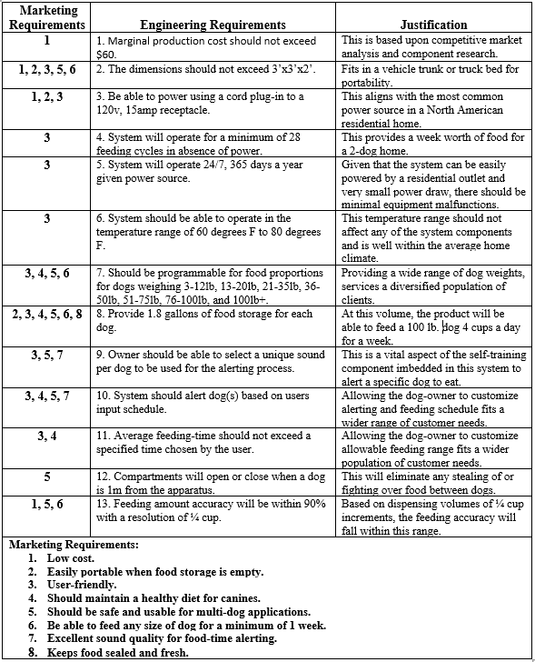

Each engineering requirement is traceable to one or more of the marketing requirements. In this manner, the engineering design and specifications are implemented to meet the needs of the shareholders, as well as the customers. Statements of justification explain why each requirement is relevant and necessary to meet technical and client needs. It is shown that the system requirements correspond to one another and why they are essential in satisfying the needs of the customers.

**Advanced Analysis:**

Engineering-Marketing Tradeoff Matrix:

The Matrix, shown in Table 2, pinpoints how the engineering and marketing requirements affect each other. The row-headings consist of the marketing requirements, while the engineering requirements are listed in the column-headings. Each requirement also has a designated polarity, indicating the overall benefit of that requirement to the final product. The arrows indicate how strong or weak the correlation is between each marketing requirement and each engineering requirement **[4]**. This data promotes further analysis in improving system performance and affordability.

**Table 2:** Engineering-marketing tradeoff matrix for the automated dog feeding apparatus (↑↑ = strong positive correlation, ↑ = positive correlation, ↑ = minute positive correlation, ↓↓ = strong negative correlation, ↓ = negative correlation, ↓ = minute negative correlation).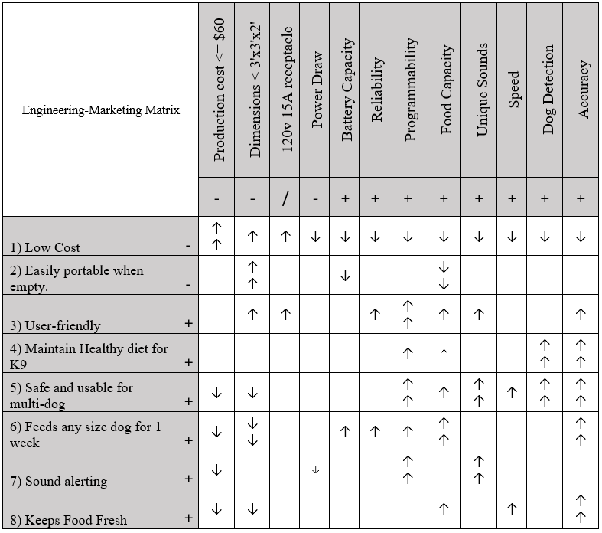

Engineering Tradeoff Matrix:

It is also necessary to make a comparison within the engineering requirements themselves. This analysis further bolsters marketing and technical needs. As shown in Table 3, a tradeoff matrix is implemented with engineering requirements consisting of both rows and columns. Similar to Table 2, positive and negative correlations are specified, as well as the strength of the correlation **[5]**. The bottom diagonal is blacked out due to redundancy. It is paramount to maximize and compare the importance of and effect each engineering requirement has on one another. In doing so, the product specifications can be narrowed down to meet functionality benchmarks.

**Table 3:** Engineering tradeoff matrix for the automated dog feeding apparatus (↑ = positive correlation, ↓ = negative correlation).

­­­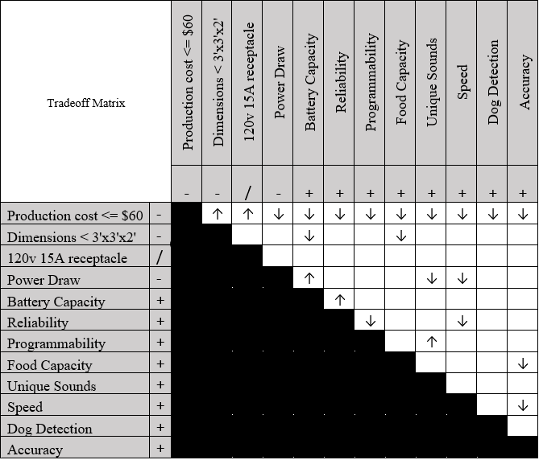

House of Quality:­

By integrating the analysis performed in Tables 2 and 3, an all-encompassing representation of data is executed utilizing the House of Quality (HOQ). This is demonstrated for the automated dog feeding apparatus featured in Figure 1. In this development process, known as quality functional deployment (QFD), product development is incorporated to meet customer needs throughout the system life cycle. The QFD process consists of design, manufacturing, sales, and marketing. The HOQ serves a critical role in the development phase of the product and is utilized in communications between different organization units **[6]**.

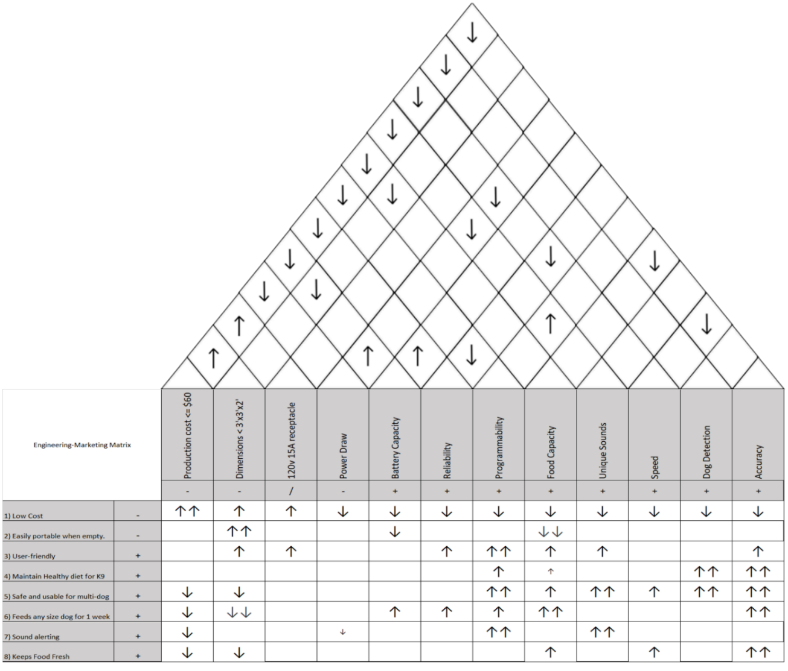

**Figure 1:** Complete House of Quality for the automated dog feeding apparatus, integrating the components from Tables 1, 2, and 3. *Table created in Microsoft Excel, edited in Adobe Photoshop*.

**Detailed Design:**

Literature Review:

The concept of a dog feeder is not a new idea. In fact, it is a take on the age-old livestock gravity feed system. There have been existing patents for electronically automated pet feeding systems as early as the 1930s **[7].** There are also several automated feeders currently on the market. What many of these existing systems fail to offer is the ability to feed your animals periodically when away from the house for an extended amount of time. Since the 1980s, many consumer pet feeding products are solely gravity fed **[8].** All the listed patents are a part of the classification of A01K5/0291 which covers all automatic devices with timing mechanisms. Most automated pet feeding devices consumers can buy use an endless screw system for the movement of dog kibble. Classification A01K5/0258 covers all automatic devices with endless screws **[9].** Although initially this design seemed optimal, it was not feasible given the budgetary and time-based restrictions imposed by the course. An alternative food delivery design can be achieved by the implementation of a device that the design team have coined as “The Super Lazy Susan” (SLS). The SLS is a 270-degree servo dumping system that is partially modeled on the common kitchen device, the “Lazy Susan”, shown in Figure 2 **[10]**.

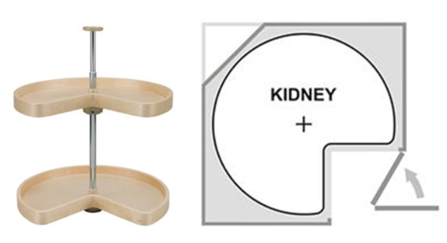

**Figure 2:** Kidney design Lazy Susan

Preceding design implementation, technical research and existing product analysis was executed in order to establish dog feeder product goals and specifications. Multiple dog-feeding apparatuses currently exist on the market. This includes elementary designs that simply gravity feed food into a bowl once the animal has eaten enough for there to be available room for more food to dispense. Most of these products provide food sealing to conserve freshness and can feed a medium-sized pet for up to 1 week.

Furthermore, there are also existing automated products for dog sustenance similar to the proposed design wherein user input dictates dispensed volumes and schedules. These types of devices are particularly useful in hands-off remote feeding. They also promote dog health ensuring proper sized meals. Additionally, many of the current apparatuses are user-friendly and provide portability. Another favorable feature provided in existing designs is the ability to control the dog feeder through smart phone apps. These types of systems are practical for single-dog homes.

The pet product company, Chewy, has various types of dog feeders currently on the market **[11]**. Some of their gravity fed options are displayed in Figure 3. These products are less than adequate in keeping food fresh, and there is no control of serving amounts, leading to both undereating when food gets stale and overeating when unlimited amounts are available, which negatively affects dog health and lifespan. Furthermore, these types of products may present a danger in food aggression for multidog homes. It may also be more expensive for clients who are consistently overfeeding or having food spoil as they need to buy more dog food than required.

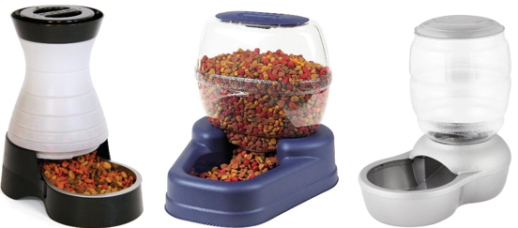

**Figure 3:** Multiple gravity fed dog food dispensers sold by Chewy.

Arf Pets manufactures and sells a more advanced pet-feeding apparatus, which provides a greater service for clients and their animals. This system, shown in Figure 4, implements a user interface for pet owners to feed their dogs the proper amount. Not only does it prevent overeating, but it also provides setup for up to four daily meals and customized portions. Setting adjustments are easily accessible through an LCD clock and display. It even has recording capabilities for tailored mealtime alerting. Furthermore, this apparatus has Bluetooth-capabilities, enabling for remote control **[12]**. This type of apparatus is functionally sound for households with one pet, but it still poses issues for families that have multiple animals.

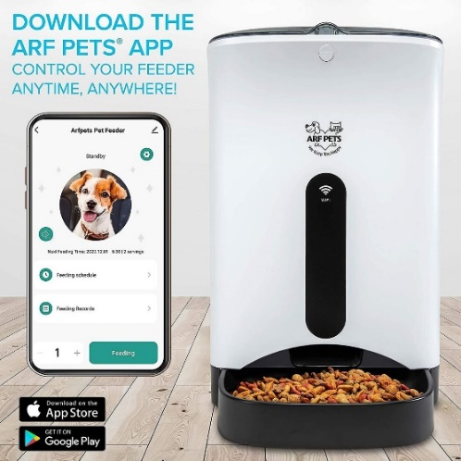

**Figure 4:** Arf Pets Automatic Smart Feeder Dog & Cat Food Dispenser.

It has been concluded that there are a wide range of dog feeding dispensers currently in the market, although some designs are more optimal than others. Gravity fed systems may be user-friendly and portable, but they do not prevent animals from overeating or stealing food. Existing automated feeders allow clients to control meal schedules and serving amounts remotely, which provides a valuable service for dog health. What hasn’t been done, is implementing the proficiencies of an automated system to provide multi-dog homes. The proposed design will provide all of the benefits of the currently available automated systems into a single unit that serves more than one animal. It will also include an alerting system, in a completely self-training aspect. Current products on the market fail to provide a user-friendly, multi-dog system, which promotes a safe environment coupled with hands-off remote feeding.

**Design Constraints:**

The production of the automated dog feeder, involved several engineering design constraints, including:

1. Size and capacity: The size and capacity of the feeder must be able to hold at least 1.8 gallons for each animal and not take up a lot of space where it sits.
2. Power source: The feeder needs a reliable and long-lasting power source, between an outlet and a battery back-up.
3. Operating voltages: All components and devices that require electricity must function using 5 to 12 DC voltage.
4. Operating currents: Under full load, the feeder must not surpass current limits of the outlet, batteries, controller, and any other components in the design.
5. Dispensing mechanism: The dispensing apparatus needs to be designed in a way that can effectively discharge the correct amount of food without jamming or clogging.
6. Food type and size: The feeder must be compatible with different types and sizes of dog kibble to cater to different dog breeds and sizes.
7. Ease of cleaning: The feeder must be easy to maintain and clean to ensure that it remains hygienic and safe for the animals.
8. Durability: The materials used to construct the dispenser should be strong and durable to withstand the wear and tear of daily use to prevent the dogs from damaging it.
9. User interface: The apparatus needs a user-friendly interface that allows the owner to set feeding times and portions and make any necessary adjustments.
10. Safety features: The feeder must be designed in a safe manner to prevent animals from accessing the food before it’s time to eat to prevent any accidents or malfunctions that could harm the dog or damage the feeder.
11. Sound sample rate: The feeder’s audio system must output sound at a frequency that is audible by both dogs and the human owners.
12. Portion controlled: The feeder needs to dispense the correct portion size for each meal.
13. Motor Specifications: The motor used in the food dispenser needs to be selected based on the weight and amount of food selected. Motor must be able to handle the load without overheating or stalling.
14. Control circuitry: The feeder must be designed in a way that the food is accurately measured and dispensed. Being able to detect and control the amount of food dispensed, while also monitoring total food levels. A failsafe should be included to prevent electrical hazards.
15. Environmental Constraints: The electrical system of the feeder should be designed to withstand the environment it’s intended to be housed in. The materials should be resistant to corrosion, oxidation, and other forms of degradation.

**Concept Generation:**

After performing a thorough technical research analysis, the design team underwent brainstorming sessions in order to generate various design concepts. In the beginning of these sessions, the quantity of ideas was emphasized, rather than the quality of the design. It was not until after building a large design portfolio, that refinement and improvements were made. In this way, the most proficient design ideas of each system were altered and combined. This is known as scamper brainstorming. The directed method of concept generation was utilized in a step-by-step technique to solve the problem. Technical research and information guided the design team through this process.

After the initial brainstorming session, forty-five-minute time-blocks were used to perform an intuitive method of concept generation. In these meetings, the existing ideas were broken down into several refined designs that could potentially work. Functionality was a key component in this step of the design. In doing so, individual ideas were expanded upon to generate more polished concepts.

One of the preliminary drafts, depicted in Figure 5 **[13]**, proved to be a starting point for the finalized design. The layout of feeding compartments consisted of two drawers, one extending out the front of the apparatus, and one extending from the back. There are also two food storage chambers for housing differing types of kibbles.

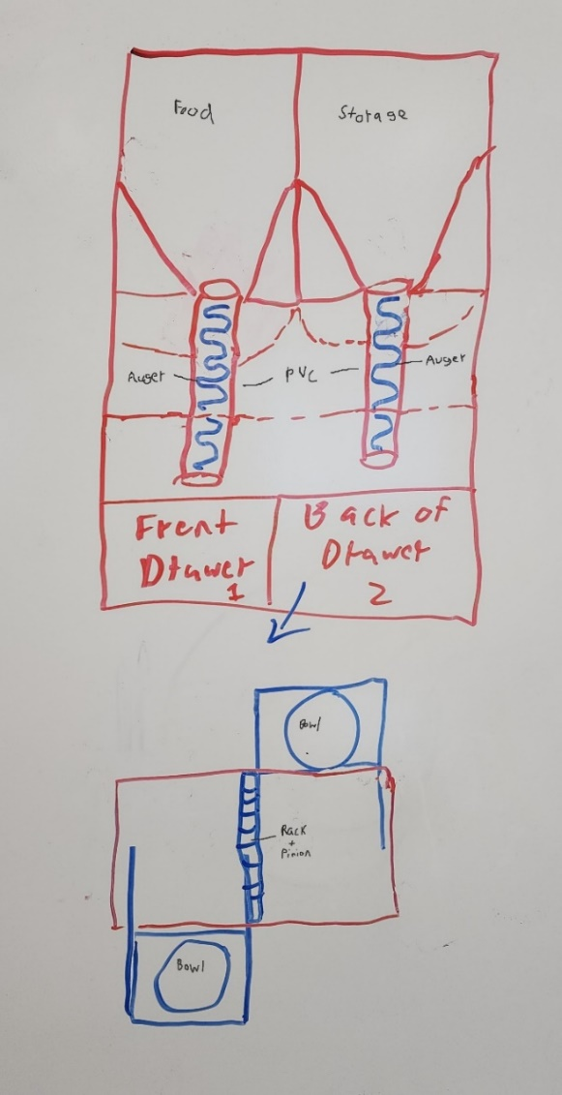 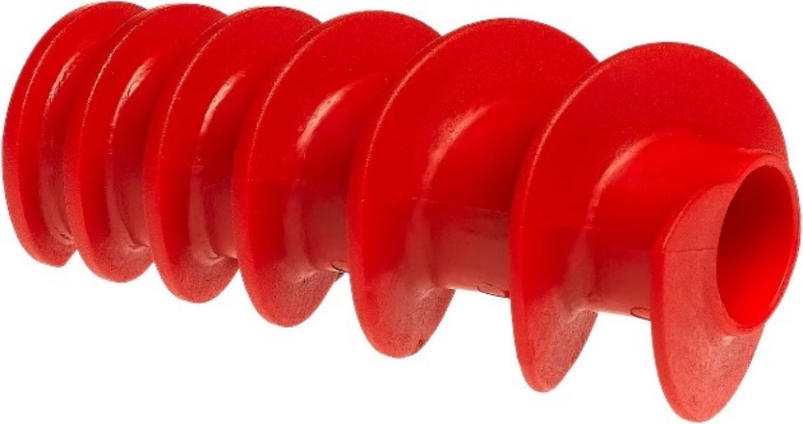

Uniform Auger

**Figure 5:** Sketch of first design draft. *Labeled in Adobe Photoshop*.

PVC pipes, extending down from each storage compartment, have augers inside them for food dispensing. These uniform augers were to be controlled by servo motors to transport the food in incremental periods into the bowls. The initial design for the bowl distribution was to have the bowls be nested within existing drawers and have them extrude out of the unit once the dog approaches. The drawers were to use a single rack and pinion shared between them, with only one side being able to be pushed out at once. This concept presented weaknesses in safety. Having drawers, presents a risk in them closing on the animals’ appendages. Additionally, utilization of augers results in the device being too tall. Since the food storage is located at the top of the dog feeder, having augers for dispensing, results in an overly top-heavy product.

Another similar initial design included using paddle wheel dispensers. This is shown in Figure 6 **[14]**. The new dispenser design would have timers controlling the duration that the wheels would rotate, depending on the amount of food needed. The mechanical design of drawer operation is the same as Figure 5, but it was decided that weight sensors would be utilized under the bowls to aid in food consumption measurement. This was the first step in the self-training component of the dog feeder. Having weight sensors enables the refilling of only the top up amount of each serving. This teaches the animals to eat the entire bowl of food during feeding time and ensures freshness. It was determined that accuracy in food allocation may be a problem utilizing the paddle wheel concept, and they may jam or snag on the storage walls. The danger risk for dogs also still exists when using the drawers.

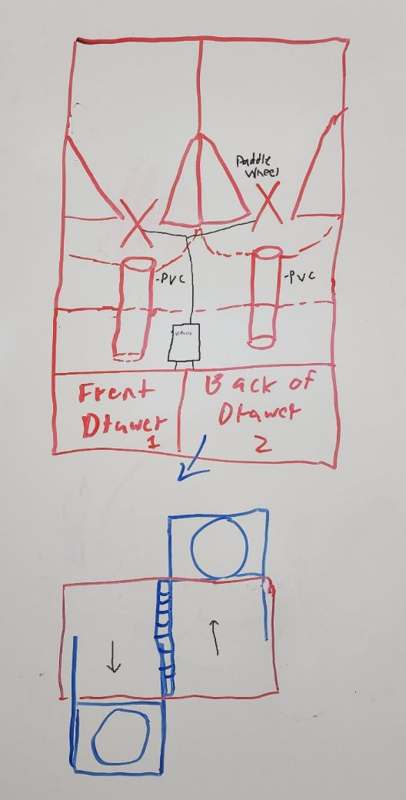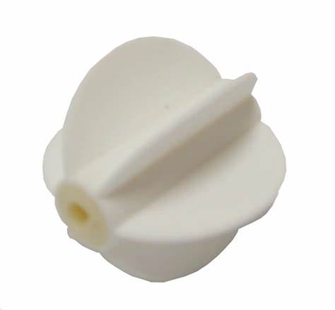

Paddle

Wheel

**Figure 6:** Sketch of second design draft. *Labeled in Adobe Photoshop*.

The third draft of the design, shown in Figure 7, saw the most substantial redesigns occur. The method of food dumping was, yet again, changed from a dual paddle wheel system to a custom-made design, that the team has titled the “Super Lazy Susan” (SLS). This dispenser serves to reduce space in the system and provide the torque necessary to still be able to move when the kibble on the higher end of the weight spectrum is used on the scale. The SLS will only dispense food in quarter cup quantities to improve accuracy and will act as a seal for the containers. Additionally, only one SLS is included to service both dog bowls.

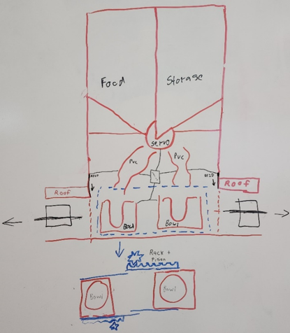

**Figure 7:** Sketch of third design draft. *Labeled in Adobe Photoshop*.

Unlike in previous designs, the bowl drawers are directly opposite one another, coming out on opposite sides of the device. The shared rack and pinion system is ditched in favor of separately controlled drawers for ease in feeding multiple dogs. In order to prevent animals from breaking into the feeder, there will be a roof that protrudes out of the sides of the apparatus. This structure will leave just enough room for the bowl to fit under it. Once the bowl is extended past the roof, the food will be available for the dog. After feeding, the bowl will be retracted back into the main housing compartment, and a door will shut behind it for an extra level of security. The sensing ability of the drawer doors was to be dictated by a Radio Frequency Identification RFID sensor with tags that could be fitted onto a dog’s collar. This concept is featured in Figure 7. This design solves many of the drawbacks of the previous ones, although further investigation is required to improve the safety of the drawers.

The fourth draft focuses on the redesign of the bowl carry system and is shown in Figure 8 **[15] [16]**. The doors on the feeder were replaced with a vinyl covering. The drawers were eliminated to improve safety. Rails are to extend the proper bowl through the vinyl on the RFID connection. The platforms holding the bowls have been replaced with a custom tomahawk-shaped platform. Resting on the larger width area of the platform is a secondary support for the bowl and weight measuring device. On the thinner portion of the structure, the racks and pinions will be held. In this design, dogs may be able to break into the device through the vinyl coverings. Further brainstorming was needed in order to resolve this issue.

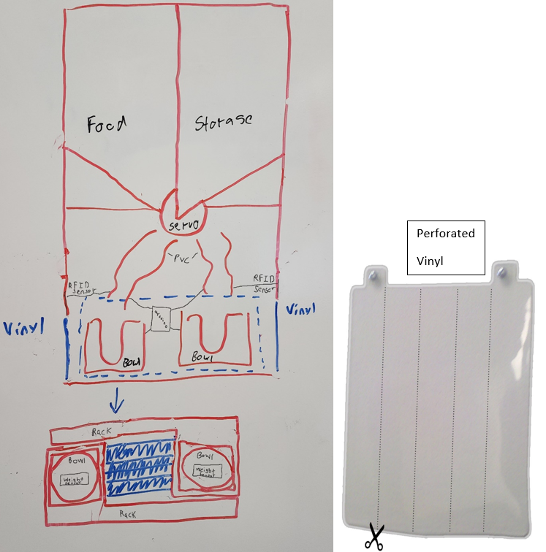

**Figure 8:** Sketch of fourth design draft. *Labeled in Adobe Photoshop*.

All brainstormed designs share some commonalities, such as separate compartments for multiple types of food to be used at once, a food safe PVC pipe for food delivery, moving bowls housed in frames, a method of dog detection, and some sort of incremental food delivery system. A strength and weakness analysis was performed to determine which design components were to be utilized in the proposed design. Each component was rated through an analytical process in order to refine and combine the most appropriate concepts into the proposed design. This was done to define the system process that most evidently satisfies the technical engineering needs. In order to perform Pugh analysis, the design in Figure 8 was chosen as a baseline concept. Each design was compared to the baseline with positive, negative, or neutral analytical scores. From this process, a Pugh Concept Table was implemented, as shown in Table 4.

**Table 4:** Pugh Concept Table showing comparison to baseline design (+1 = better than, 0 = equal to, -1 = worse than).

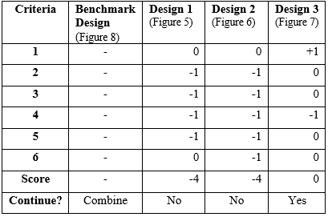

The Pugh analysis was based on the following criteria:

1. Functionality.
2. Utilization of space.
3. Cost.
4. Safety.
5. Efficiency.
6. Accuracy.

From the Pugh analytical analysis, it was determined that certain design aspects from concept 3 (Figure 7), would be combined with the benchmark concept (Figure 8). After performing this exploration, a more complete design was decided upon in order to meet the specified criteria. A sketch of this collaborative design is featured in Figure 9.

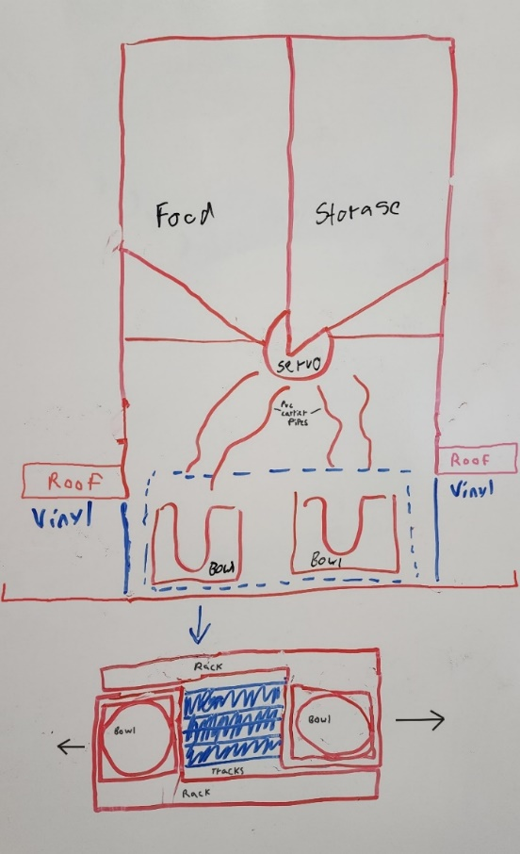

**Figure 9:** Sketch of proposed design. *Labeled in Photoshop*.

The top of the apparatus consists of two food storage compartments. The SLS will service both compartments and will be controlled by a servo motor. The SLS will dispense food amounts in quarter cup increments into the heat molded PVC conduits. The PVC acts as a funnel for the food to fall into the proper bowl. Each bowl will sit on a platform, which will be fastened to two extendable tracks. A motorized wheel is to be used to extend and retract each platform for feeding. The tracks will push the bowl through a vinyl curtain that will act as a barrier between the dog and the dispensing chamber. Additionally, a roof will protrude from the sides of the feeder, leaving just enough space for the bowl to fit under it. The bowl will extend past this roof during mealtimes. Having this small space under the roof will prevent animals from breaking into the dispensing compartment and eliminate any pinch points. RFID sensors will be utilized for dog sensing and to initiate track extension. Lastly, weight sensors will detect how much food remains in the bowls.

**Design Description:**

Physical Design:

Once a more complete design was sketched and decided upon, a higher quality, and more realistic representation was constructed using Solid Works Software. Individual components were modeled before assembling them into one unit. The physical image of the feeder as shown in Figure 10, is a complete assembly of the system components. The top portion of this design consists of two storage compartments for housing dog food and the SLS for food distribution. Additionally, the LCD screen, buttons, and Arduino controller are located in this section. The mid-section includes two funnels for food allocation. Lastly, the lower portion of the feeder holds the bowls. Each bowl sits in a housing unit that contains weight sensors and is attached to a platform. The platforms are fastened to two sliding rails that are controlled by a Direct Current (DC) powered wheel.

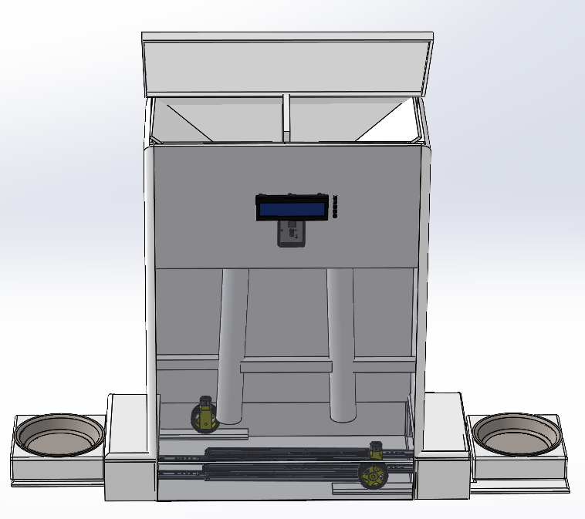

**Figure 10:** Proposed physical design. *Created in Solid Works Software.*

Figure 11 shows the skeleton of the feeder frame, as well as the angled ramps for the feeding compartments. The angled ramps, which make up the food hopper compartments, will be fastened inside the top portion of the frame. Calculations for overall feeder dimensions and food compartment volumes were performed. Additionally, experiments were performed in order to determine the ideal degree of angle for the ramps.

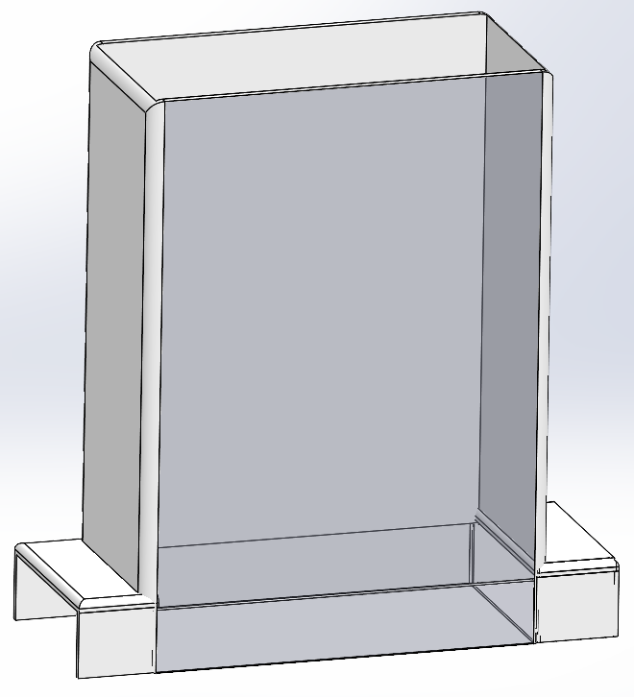 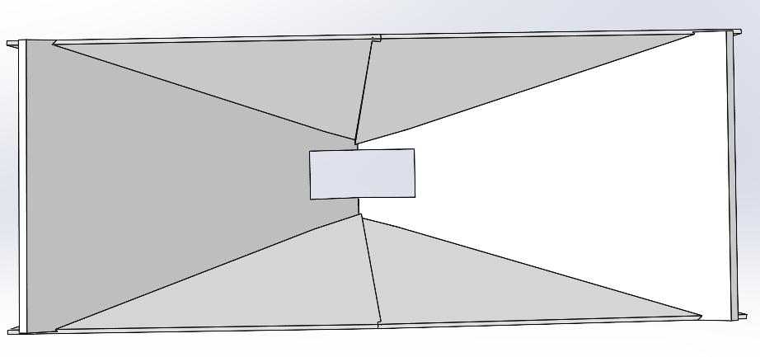

Hopper

Feeder Frame

**Figure 11:** Feeder frame and hopper. *Created in Solid Works Software.*

The SLS will be located below the food compartments and will service both bowls. It will be controlled by a servo motor with 270° rotation capabilities. This will allow the SLS to dispense food from either food section. Directly below and slightly to each side of the SLS, two funnels will be used to direct the food into the proper bowl during dispensing. These components are featured in Figure 12 **[17, 18]**.

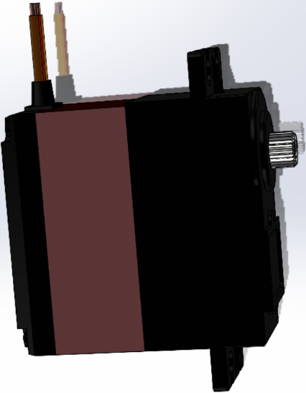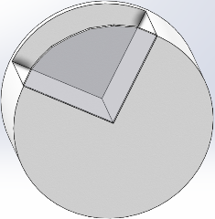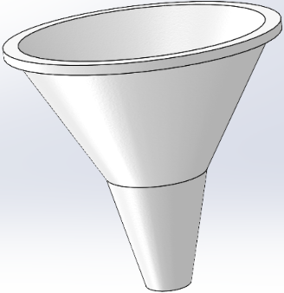

Funnel

Servo Motor

“Super Lazy Susan”

**Figure 12:** Servo motor, SLS, and funnels. *Created in Solid Works Software.*

Located under the funnels will be a bowl for each dog. The bowls will sit in a fitted holder, ensuring their security. Within the base of the holder, a weight sensor will be embedded in order to track food amounts. This ensures that each dog has eaten the proper amount of food. These components are shown in Figure 13 **[19]**.

Weight Sensor

Bowl Holder

Bowl

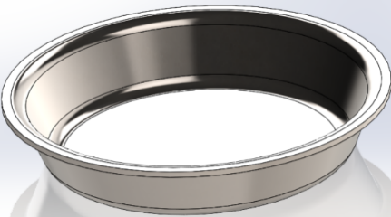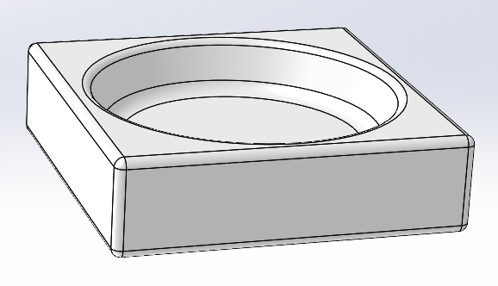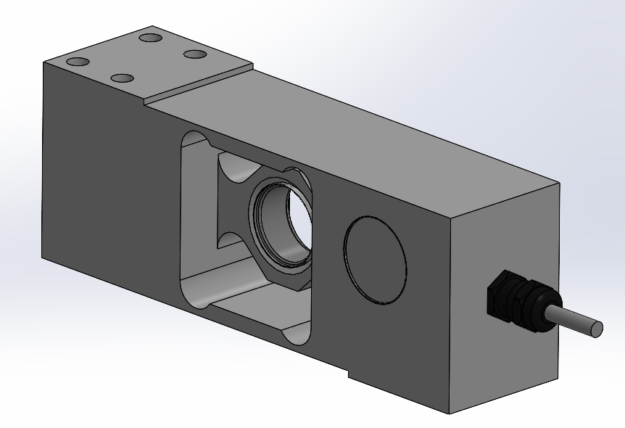

**Figure 13:** Bowl, bowl holder, and weight sensor. *Created in Solid Works Software.*

The devices, presented in Figure 14 **[20, 21]**, are housed beneath the bowl holder. Four extendable tracks will be mounted to the base of the feeder frame. A platform, for each bowl holder, will be fastened to two of the rails. Both platforms have a narrow protrusion that is used as a track for the DC motor operated wheel. The wheel will be mounted to the base of the feeder frame and fitted to the protrusion. The stationary wheel will use the track to extend and retract its designated bowl and platform unit. The use of a rubber wheel is for expedient and inexpensive prototyping; an ideal solution is the use of a rack and pinion, with the rack being machined into the platform extension.

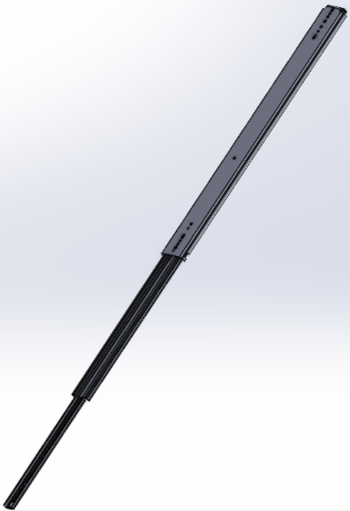 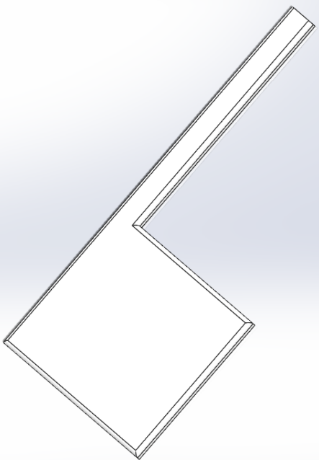 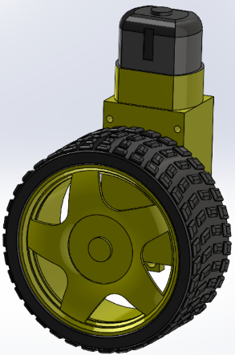

Motor

Wheel

Platform

Telescoping rail

**Figure 14:** Platforms, telescoping rails, motor, and wheels. *Created in Solid Works Software.*

An Arduino Mega, a microcontroller development board, will be programmed in order to operate all system components. This includes energizing and de-energizing the servo motor for SLS rotation and functioning the DC motors for platform extension and retraction. Additionally, it will receive input signals from the RFID tags and weight sensors for proper feeding amounts and times. A user-interface LCD screen and buttons will allow pet owners to select feeding schedules and amounts. These images can be seen in Figure 15 **[22, 23, 24]**.

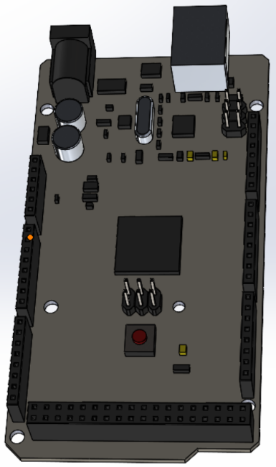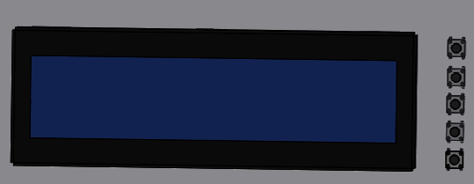

Buttons

LCD

Arduino Mega

**Figure 15:** Arduino Mega microcontroller and LCD/Button Interface. *Created in Solid Works Software.*

Figure 16 consists of two images of the completely assembled dog feeder. As shown, one figure shows the left bowl extended for feeding, and the other shows the right bowl extended for feeding. In this way, each dog will have different feeding times.

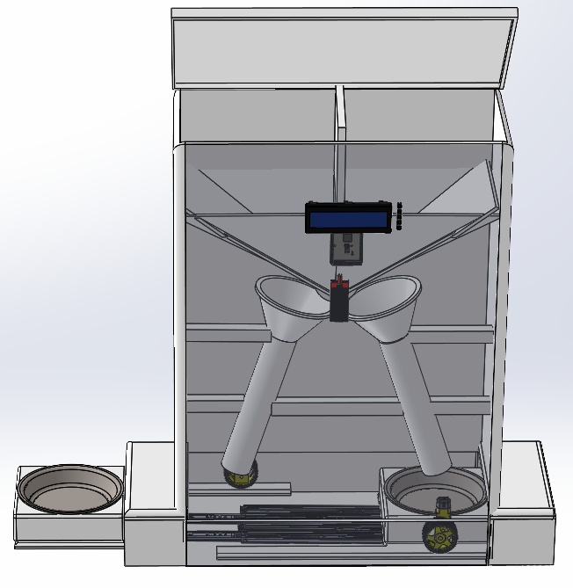 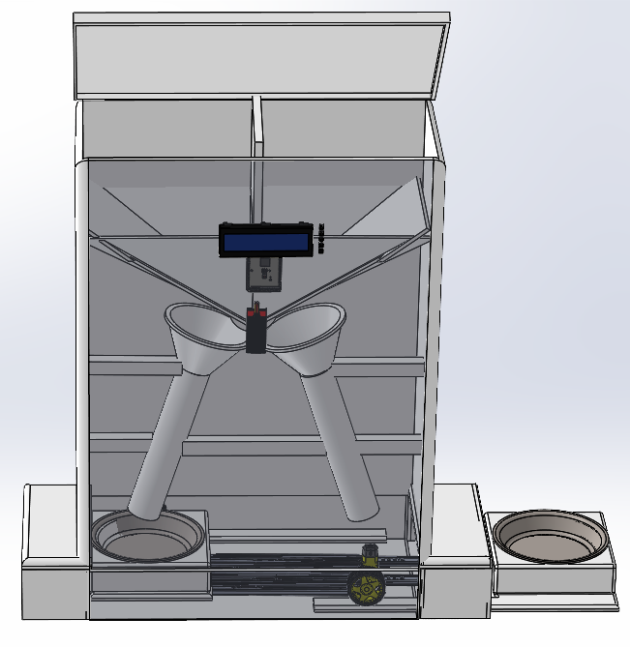**Figure 16:** Dog feeder with components assembled, showing left bowl extended, and right bowl extended. *Created in Solid Works Software.*

Functional Decomposition:

The level 0 functionality process flow diagram is featured in Figure 17, which showcases the dog feeder as the main module. The design requires a 120 Alternating Current (AC) voltage power source, operating from a 15-amp circuit. User input dictates the feeding amount for each dog. The level 1 modules are housed within the level 0 dog feeder module.

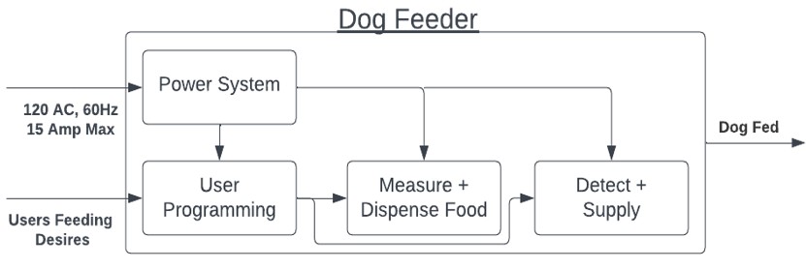**Figure 17:** Flow diagram for dog feeder level 0 functionality including imbedded level 1 modules. *Created with Lucidchart.*

Table 5 consists of a breakdown of the level 0 decompositions. This includes the inputs of the power source and user input for feeding amounts and schedule. The output includes the dispensing and availability of food for the animals. The functionality description explains how the inputs are utilized to achieve the desired output.

**Table 5:** Level 0 Dog Feeder Functionality.

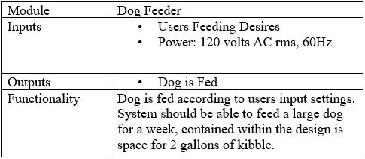

The level 1 functionality process flow diagram for the power system is shown in Figure 18. This system receives the 120 AC voltage input and transforms and rectifies it into the appropriate direct current outputs. The level 2 modules within the power system include the charging circuit, DC battery, and conversion process. The power system outputs 5 volts DC and 12 volts DC.

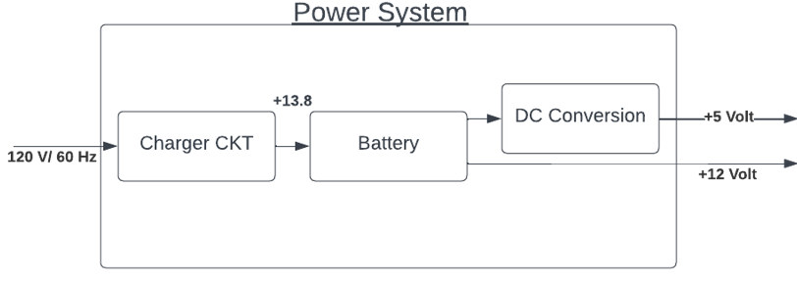**Figure 18:**  Flow diagram for dog feeder level 1 power system functionality including imbedded level 2 modules. *Created with Lucidchart.*

Table 6 includes a breakdown of the level 1 power system decompositions. This includes the input of the power source and the DC outputs. The functionality of the power input and output processes is explained.

**Table 6:** Level 1 Power System Functionality.

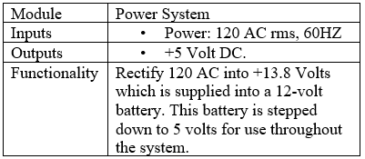

The level 1 functionality process of food measurement and dispensing are shown in Figure 19. The system inputs consist of food and user setup. The level 2 modules within the measurement and dispensing module include the sealed hopper, control, food measurement and dispensation, detection of food, and feeding container. The output is the appropriate measured food quantity.

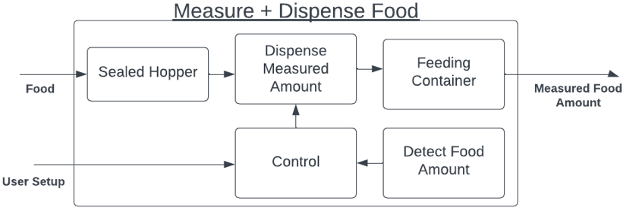**Figure 19:** Level 1 Measurement and Food Dispensing functionality and Level 2 details. *Created with Lucidchart.*

Table 7 consists of a breakdown of the level 1 measurement and food dispensing functionality. This includes the inputs of dog food and user setup execution. The functionality of the input and output processes is explained.

**Table 7:** Level 1 Measurement and Food Dispensing functionality.

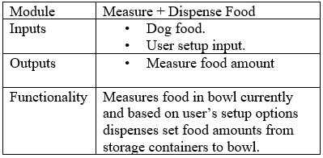

The level 1 functionality for dog detection and food supply is shown in Figure 20. The system inputs consist of user settings. The level 2 modules within the detect and supply module include control, call dog, detect dog, and feeding device. The output is making the food available for eating.

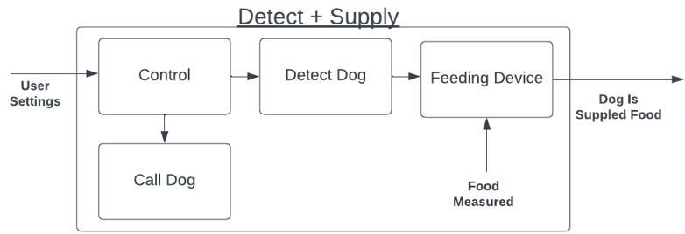**Figure 20:** Level 1 Dog Detection + Food Supply functionality and Level 2 details. *Created with Lucidchart.*

Table 8 shows a breakdown of the level 1 detect and supply functionality. This includes the inputs of user settings and food measured. The functionality of the input and output processes is explained.

**Table 8:** Level 1 Dog Detection + Food Supply functionality.

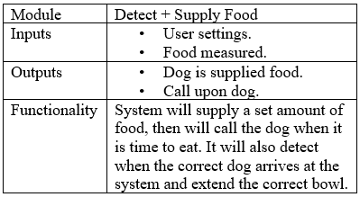The level 1 functionality for user programming is featured in Figure 21. The system input consists of user-desired settings. The level 2 modules within the user programming module include user input, control, user output, and system. The output is the user-selected settings.

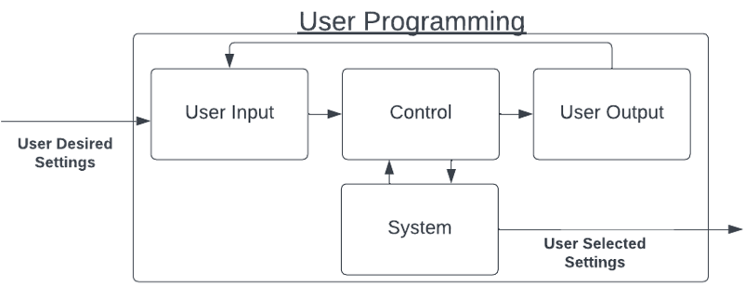**Figure 21:** Level 1 User Programmability functionality and Level 2 details. *Created with Lucidchart.*

Table 9 shows a breakdown of the level 1 programmability functionality. This includes the input of desired user settings and the output of user-selected settings. The functionality of the input and output processes is explained.

**Table 9:** Level 1 Programmability Functionality.

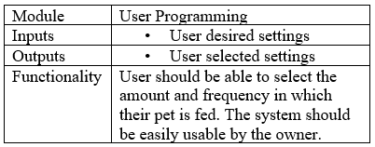**­­**

Electrical Design Elements:

The central electrical board will be an Arduino Mega development board that houses the ATmega2560 microcontroller and associated support circuitry as well as an LM1117 linear voltage regulator that supplies 5 volts to the microcontroller and logic circuits. Power will be supplied by a 12-volt battery that is constantly charged from mains power using a voltage-limited charger in Figure 22. The LCD screen, the weight sensors, all switches and buttons, and all 5-volt circuits will be powered through an L7805CV linear voltage regulator **[25]**. The servo motor operating the SLS will be powered by an L78S75CV linear voltage regulator supplying 7.5 volts **[26]**. Due to both a greater current draw and a requirement to operate in two directions, the DC motors on the pinion of the bowl platform, rack and pinion will be powered through a separate motor driver circuit drawing power directly from the battery. The Secure Digital (SD) card module, Real-Time Clock (RTC), RFID antenna, and Inter-Integrated Circuit (I2C) LCD driver will be commercially available boards, as noted in the cost analysis. The production electrical design should integrate all components into a single power and control board.

Figure 22 features the circuit for constant charging of the backup battery; a transformer and full bridge rectifier provide a DC power source, and a Darlington transistor with its base clamped at 15 Volts by a Zener diode provides a charging current. The maximum voltage that will not cause gasification of a lead acid battery is 14.4 Volts and is the target charging voltage **[27]**. The base-to-emitter voltage drop of the TIP121G Darlington power transistor of 0.7 Volts gives a target base clamping voltage of 15.1 Volts **[28]**. A 15-Volt Zener diode is commercially available **[29]**. The DC voltage must exceed this voltage and not exceed the 80-volt maximum of the TIP121G. As the collector will charge to the peak voltage of the rectifier input a 10 to 1 stepdown transformer from the 120 Volt RMS/169-Volt peak will supply no more than 16.9 Volts. This circuit was verified using NI Multisim. Due to equipment availability and for purposes of expedient prototyping, this circuit will be substituted for a commercial battery trickle charger in the prototype.

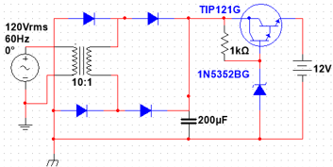

**Figure 22:** Diagram of battery charging circuit. *Created in NI Multisim.*

The Motor control driver circuit uses a basic H-bridge to achieve two-directional control of the pinion drive DC motor to operate the food bowl platforms using two digital output lines of the microcontroller. This is featured in Figure 23. One driver will be included for each pinion motor, for a total of two. Metal-Oxide-Semiconductor Field-Effect Transistors (MOSFETs) are used for their high current capacity so that the circuit is resilient to the high currents drawn during motor stall after opening the platform, and for the internal diode, which will work as flyback diodes on motor shutdown. The “Forward” and “Reverse” connections will be operated by Pulse Width Modulation (PWM) capable lines on the Arduino board so that motor speed can be modulated.

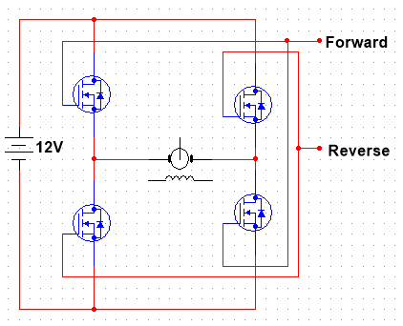

**Figure 23:** Diagram of motor direction controller. *Created in NI Multisim.*

Software Design Elements:

The software design consists of three modules: a central loop that runs continuously and two routines that are called when needed. The central loop in Figure 24 runs continuously, beginning with a processor sleep time used to minimize power consumption.

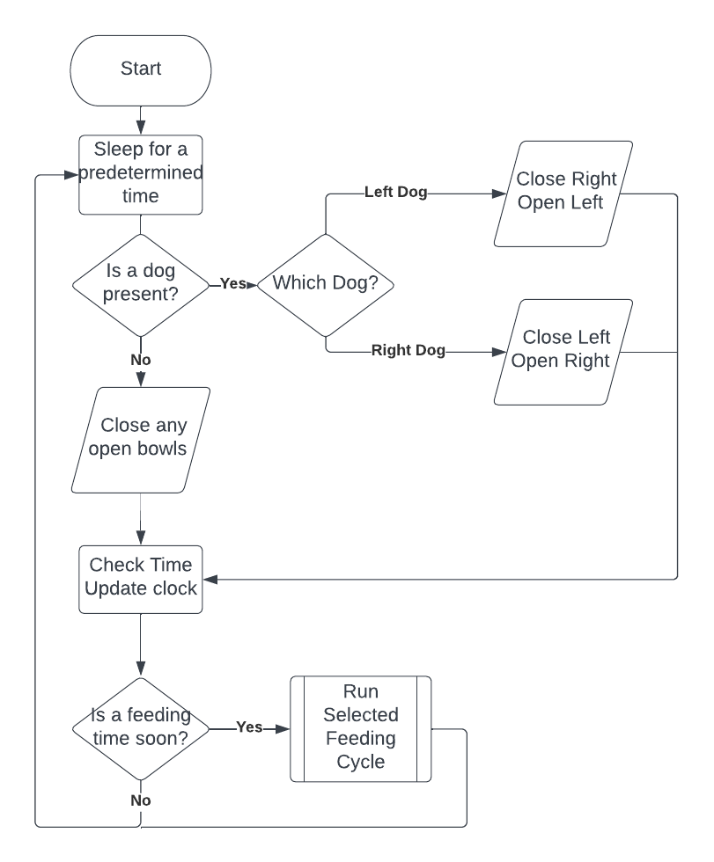

**Figure 24:** Central Loop Flowchart. *Created with Lucidchart.*

The loop then queries the RIFD module for the presence of either dog’s RFID tag and responds to the presence of a dog by extending the feed platform if the correct dog is present and closing the other dog’s feeding bowl. If no dog is present, during feeding times, both platforms will be closed to preserve the freshness of the remaining food. Boolean values will be used to hold the position of the bowl platforms so that an attempt to close or open a platform that is already in the desired position is not commanded. After checking for dogs, the process then reads the time from the real-time clock into memory and updates the LCD display. The current time is then compared to the scheduled feeding times, and if one is within the duration of the feeding cycle, then the feeding cycle is called. The user interface in Figure 25 contains a menu for the user to set desired options.

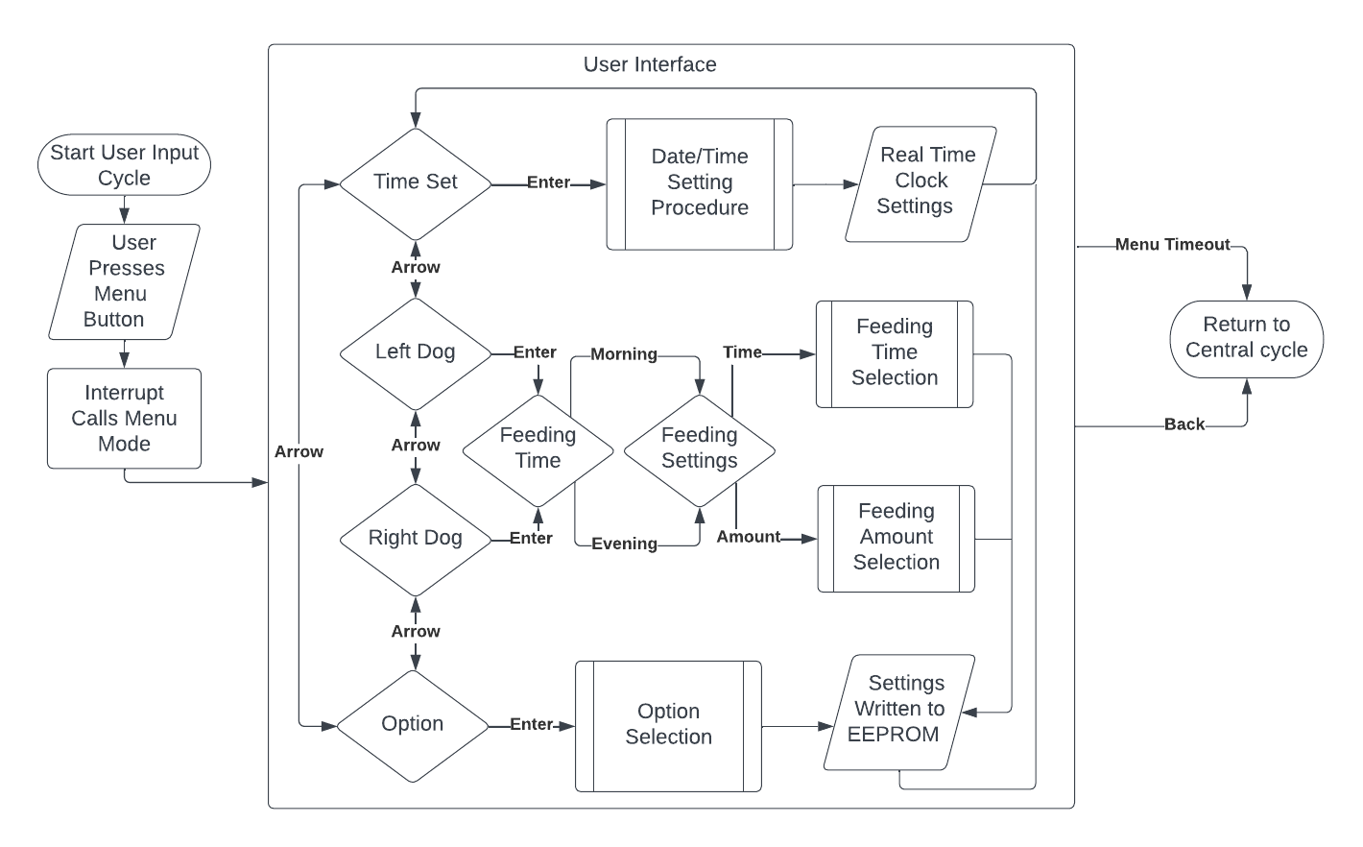

**Figure 25:** User Interface Flowchart. *Created with Lucidchart.*

The user will interact with the system through the use of 5 buttons: Menu, Back, Up, Down, and Enter. Pressing the Menu button at any time will call the menu by the action of an interrupt and Interrupt Service Routine (ISR). The user will be presented with 4 options: Time Set, Left, Right Dog, and Option. The Up and Down arrows will navigate through the menu, and the Enter button will be used to select. Selection of Time Set will launch an interface to set the date and time, which will be updated in the real-time clock module when complete. Both dog selections will branch to a menu with two feeding times, morning and evening, which both branch to a menu to set the time and amount of food to be fed, including the options to react to food remaining in the bowl during the feeding cycle.

The feeding cycle, featured in Figure 26, handles the measurement and dispensing of food and calling dogs at feeding time. When a feeding cycle is begun, the bowl is weighed to determine the amount of food remaining and the amount of food to be dispensed. If the bowl is determined to be full, the feeding amount is set to zero so that the bowl is not overfilled, resulting in food spilling inside the feeder. The cycle then queries the user’s settings for feeding quantity and procedure. In the case of a user’s selection to always feed the selected amount, the dispensed amount is set to the minimum of that amount or the amount of space remaining before the bowl is full. In the case of user selection to fill the bowl to the dog’s serving amount, the feeding amount is set to the difference between that amount and the remaining food. In the case of the user’s selection to wait until the bowl is empty to refill, the presence of remaining food is determined within the range of accuracy of the weight sensor, and the feeding amount is set to none if food remains and to the selected quantity if the bowl is determined to be empty. Once the feeding amount is determined and rounded to the nearest dispensable amount, this amount is dispensed into the bowl by the SLS, and the selected call is played to alert the dog to available food. After the completion of the feeding cycle control is returned to the central loop, which handles opening the feeding bowl platform when the dog arrives.

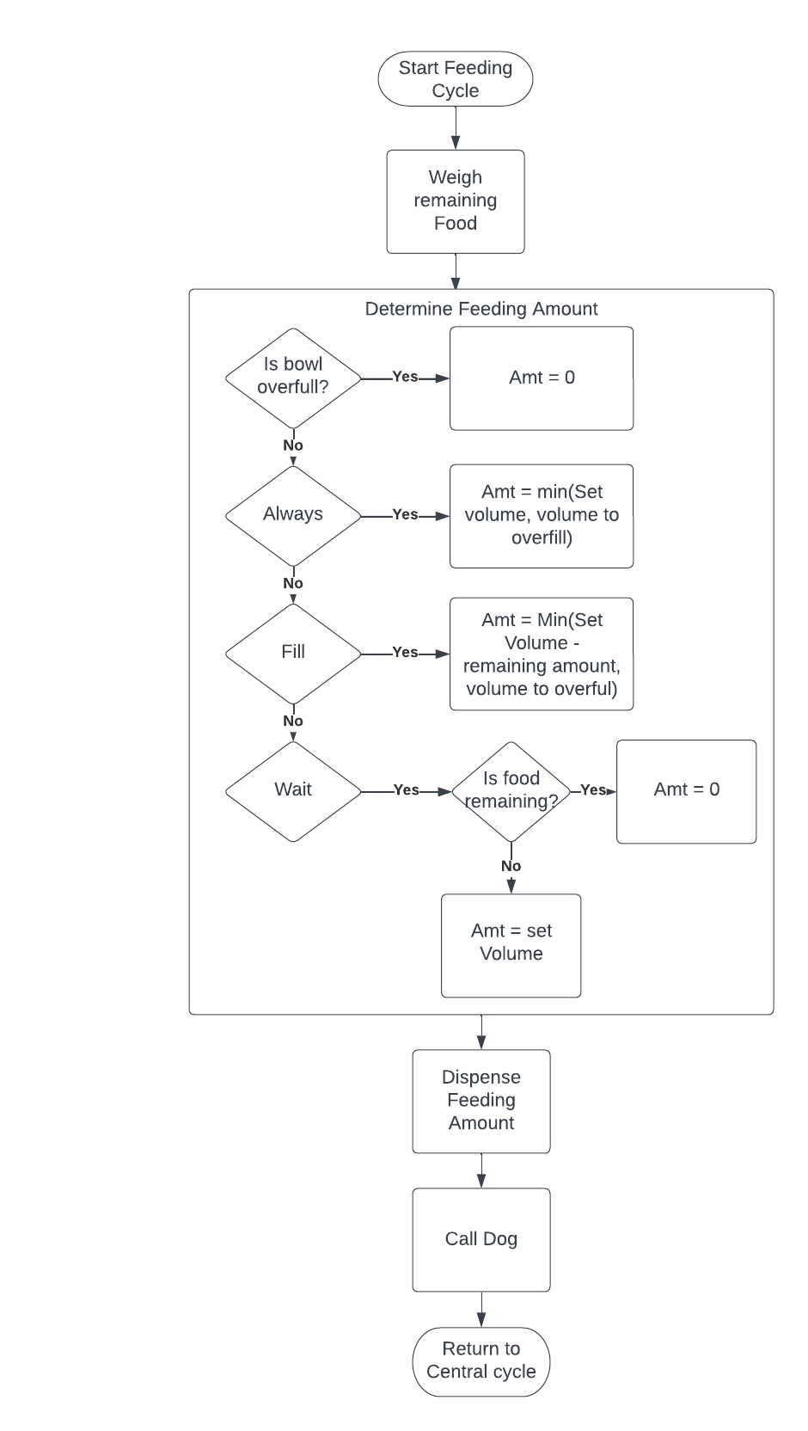

**Figure 26:** Feeding Cycle Flowchart. *Created with Lucidchart.*

**Iterative Nature of Design Changes:**

The preliminary design of the bowl extension construction and location was altered numerous times. There were many options for how the food would be presented to the animal, such as differing drawer and door types for opening and closing. After an analysis of safety improvements was performed, a change was made from an actual drawer or closing mechanism to a vinyl curtain and overhanging roof. This was done in order to make the feeder safer by eliminating pinch points. In doing so, the amount of hardware and moving parts implemented in the system was minimized, improving efficiency and cost. The location of the extension of the bowls was also altered several times and is shown in concept generation. These changes were brought about to reduce the amount of space required for the feeder. The final location of bowl extrusion was ultimately decided to have each bowl extend out on opposite sides of the feeder, running parallel with the wall or structure that it is up against. In this way, the product becomes more user-friendly and economical in terms of space consumption.

Another major feature that required major design alterations was in the food dispensing components. The original design consisted of using two augers, one for each dog bowl, to facilitate both food compartments. The use of two augers would not be economical in space. Additionally, it increased the cost of the product. As a result, paddle wheels were selected to dispense kibble from each food chamber. This helped minimize the size of the product. The rotation of the paddle wheels was to be set on timers. Unfortunately, it was discovered that the accuracy of food volumes may be an issue. To find a solution, the design team decided to produce its own dispensing device. It was ultimately decided that a single SLS would be used to service both bowls. This improved affordability, decreased the height of the feeder, and improved the accuracy of feeding amounts.

The food hoppers were originally envisioned as separate, sealed containers contained within the structure of the automated feeder frame. Taking inspiration from airplane wing fuel tanks, the design was changed so that the hopper was made of the outer structure of the feeder, reducing complexity, material usage, and cost while increasing the possible volume of the containers.

The battery charging circuit was originally envisioned as only a full-bridge rectifier with a transformer designed to reach peak voltages just below the gasification voltage of lead acid batteries, this design was abandoned as short circuits could occur during AC power loss. The current design does not short out during AC power loss and automatically shuts down when the battery is fully charged. Continuing the iterative design would add microcontroller control of the charging circuit and monitoring of the battery. The DC motor controllers were initially expected to be made using Bipolar Junction Transistors (BJTs) however during testing of the DC motors, they were found to pull currents greater than 1A during stall immediately before shutdown, which would require high current-capable transistors and flyback diodes. Both problems were solved by changing to MOSFETs. Calling the user interface and monitoring button presses were initially considered to be part of the main loop of the software; while building flowcharts, the idea of compartmentalizing the user interface was pitched, and the idea of using an ISR came up in the resulting discussion. Upon verification that interrupts were supported by the microprocessor, it was decided to do so.

There were multiple design changes during the construction of the prototype. The design of the SLS was originally made out of two pieces of two-by-four inch wood to assemble a T-like shaped apparatus. The diameter of the SLS was to be reduced until one of the four sections was the correct volume to hold a one-quarter cup of dog food. It was found that this version of the SLS was too large to reduce the food-holding section to the required volume. Additionally, the center section of this design proved to be too small for drilling a hole for the drive shaft rod to fit through. As a result, a new design was implemented by cutting multiple circles of plywood and gluing them together to form a cylinder. A small section was cut out of the cylinder for holding the proper volume of kibble. The improved design has enough room for the drive shaft as well. Both the original and finalized design concepts for the SLS are featured in Figure 27.

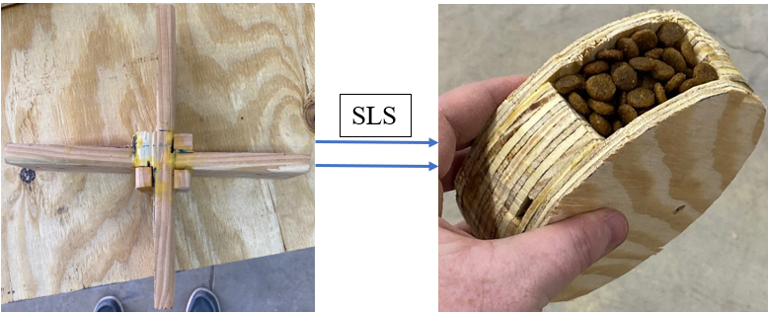

Improved Design

Original Design

**Figure 27:** SLS Design Change.

Another design change, shown in Figure 28, involved the layout of the telescoping rails. The preliminary design had the rails centered under the bowl and platform. With this placement of the rails, the narrow section of the platform, where the motorized wheel sits, was floating with little support. After testing the extension and retraction of the platform, it was discovered that the narrow protrusion was too flimsy to handle the pressure of the wheel. To solve this issue the two outside rails were relocated directly under the platform extensions. This made them much sturdier. Additionally, having a rail directly below the motorized wheels resulted in the wheel operating much smoother.

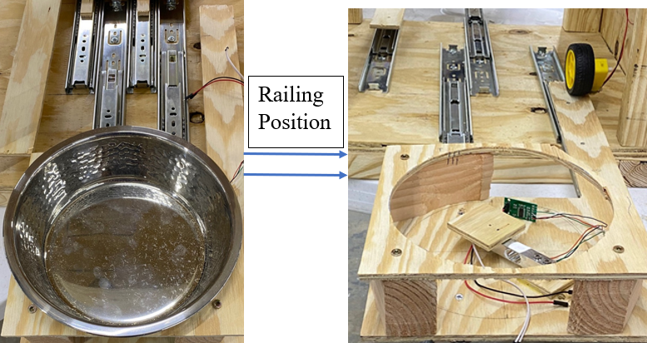

Original Layout

Improved Layout

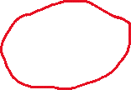

**Figure 28:** Telescoping rails mounting location change.

The DC motor used for extending and retracting the food bowls also had to be redesigned. The original motor that was used had plastic gears. After mounting the motors and fitting the wheels to the platform protrusions, the motors function properly numerous times. Both motors adequately moved the platforms, but after a multiple test trial runs the plastic gears within the motors were damaged. To solve this problem, plastic motors were replaced with metal motors that operate using metal gears. The old and new motors are shown in Figure 29.

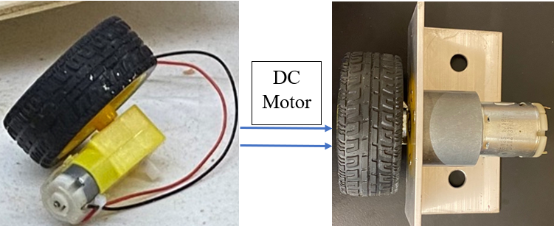

Upgraded Motor

Original Motor

**Figure 29:** DC motor upgrade.

The original mounts for the DC motors were constructed of wood and were used to friction-fit the wheels to the platform protrusions. It was difficult to get the friction pressure just right with the wooden mounts. Additionally, the wheels did not fit perfectly flush. This resulted in uneven extension and retraction of the platforms. As a result, the mounts were redesigned using aluminum L-shaped channels. Carriage bolts were installed from the bottom of the feeder frame to secure the channels. Using nuts on the bolts the pressure of the wheel on the platform was more precise and the wheels sat flush resulting in improved functionality. The old and improved mounting devices are shown in Figure 30.

Original Mount.

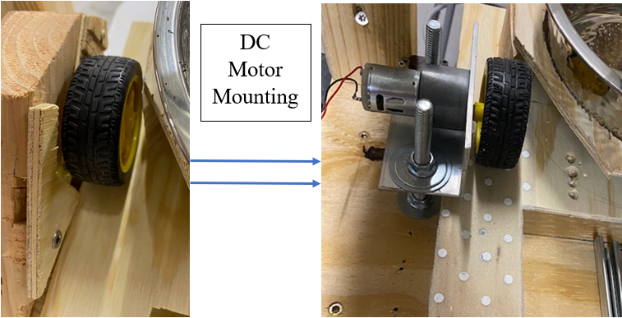

Improved Mount

**Figure 30:** DC motor mounting improvement.

**Cost Analysis:**

Materials for the prototype were chosen with a priority on availability, timely delivery, and capability. As such, the prototype materials are intentionally over-specified and chosen from suppliers with higher prices but in smaller quantities and with faster shipping. Due to the ease of acquiring parts and the team needing to work on similar parts in multiple hardware development environments simultaneously, there are also some part redundancy. This is also because most parts that could be acquired within the specified time frame could only be ordered in multi-packs. Due to unforeseen failures, this ended up being very useful. Table 10 includes the expected Bill of Materials (BOM) to complete a functional prototype.

**Table 10:** Prototype Bill of Materials.

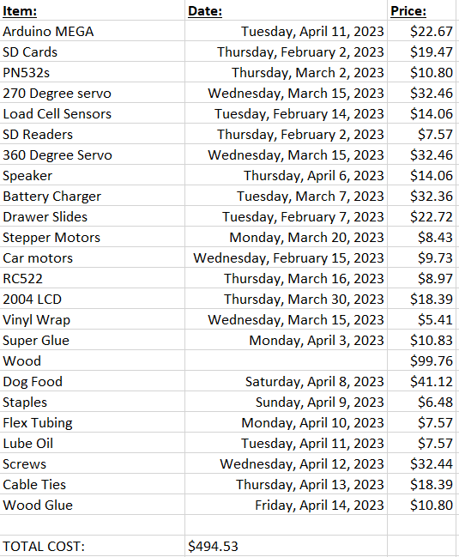

**Ethics and standards:**

Ethics:

Before placing this product on the market, extensive testing must be completed to ensure that it is safe, reliable, and meets the needs of pets and pet owners. This device should not be used as a direct alternative to human interaction with feeding and training. It should be used as a supplementary tool to aid in training and to assist the owner when they are otherwise preoccupied. The device should not harm the dog in any way, from the tray not pinching the dog to the calling sounds not damaging their ears. The dog feeder allows pet owners to feed dogs remotely for a minimum of one week, although it is not promoted or recommended to leave pets unattended for this period of time. Its convenience in allowing remote feeding is not a supplement for taking care of dogs.

Keeping animal welfare in mind, the feeder must meet the nutritional needs of pets. Not only must the apparatus feed the animals the appropriate amounts to maintain a healthy diet, but the food housing compartments and distribution system must be made of food-safe materials. Elimination of food waste is also important. To do so, the design should rid the system of overfilling bowls or spilling kibble. Food compartments should be sealed from the outside environment ensuring freshness and eliminating contamination.

Pet owners should consider their dog(s) individual needs and behavior before purchasing an automated dog feeder. The design places emphasis on keeping dogs healthy and safe but might not apply to every situation. Some pets may not develop a response to the alerting system. Others may become anxious or aggressive when they see food. For these pets, only having a certain amount of time to consume the kibble may not be adequate. Users must make sure that the feeder is sufficient in meeting the needs of their animals.

Standards:

Product standards are one of the most rigorous and important standards to follow when creating a consumer product. Not following these standards can compromise the safety and consistency of your product. An important standard, the Due Care practice standard, is followed to ensure the legitimacy of their product at every step of the supply chain. Products should not be created with unlawfully sourced material. Through the Code of Federal Regulations (CFR) [30] there are several regulations surrounding consumer products with electronic components that must be adhered to. For the use of an RFID detector, 47 CFR part 15 must be followed. Which consists of several standards that all pertain to the regulation of radio frequency energy emissions in the 9 KHz to 3000 GHz range. Depending on the retailer selected, a product may be subject to Underwriter Laboratories (UL) standards. These include standards for isolating signals and feedback, safety requirements for electronics, and standards for insulation systems. Products that are authorized under 47 CFR Part 15 must contain the product’s name, model number, the name, address, contact information of a US-based responsible party, and a statement that the product complies with 46 CFR Part 15. For bulk parts ordered, importers and manufacturers of certain types of electronic products in the United States must issue aSupplier’s Declaration of Conformity (SDoC). SDoC requires the party responsible for compliance to ensure that the equipment complies with the appropriate technical standards. 21 CFR 175 requires that adhesives or other coatings within the product meet FDA food safety standards. For most consumer products imported or manufactured in the United States country of origin labeling is required.

**Hazards and Failure Analysis:**

A major concept consideration of the proposed design included providing a safe environment for both humans and pets. In fact, one of the main problems being solved by this product is food aggression in dogs. The dog feeder was designed in such a way to remove people from the feeding environment completely. Allowing individuals to feed their pets remotely, for a minimum of one week, minimizes the danger to humans during feeding times. It was also paramount to style the product in such a way to keep dogs safe from potential food aggression episodes at feeding times. This was done with the use of RFID detection sensors located on the animals’ collars. In this way, altercations between the dogs over food are reduced because the proper food compartment will only open if the correct dog is within 1 meter of the apparatus during its scheduled feeding time. If the incorrect dog is within 2 meters of the feeder, the compartment will not open. Additionally, if the compartment is already open, it will also close if the wrong animal is sensed within the 2-meter range. At these distances, it is impossible for both animals to be eating out of the same food bowl at the same time. This keeps the dogs in a certain proximity to each other when food is available, which helps eliminate any confrontations. It is also meant for the dogs to eat at different times, further protecting the animals from dangerous situations.

It is also essential that the food be kept fresh and uncontaminated in its housing compartments. The storage compartments were chosen with the use of sealable, food-safe material that will not cause any chemical changes to the food itself. This eliminates any potential toxic or dangerous contamination to the dog kibble. Furthermore, since the bowls will be extending and retracting in and out of the sides of the feeder, it was important to remove any potential pinching hazards for the animal. This was done by removing any drawers or doors from the design that open and close in such a way that could result in animal appendages being caught or pinched in them during operation. To do this, vinyl flaps are used on the sides of the feeder. The bowls extend through these vinyl flaps. Once past the flaps, a roofed-housing unit will cover the bowl, leaving just enough space for it to extend out of the feeder. The food will protrude past this housing unit and be available for feeding at that time. Since there is no room for an animal’s limbs to fit under the extended roof, pinch points were eradicated during the design process.

Maintaining safety for users and the environment was also considered further. To do so, operating voltages were kept low to reduce any chance of electrical shock or the production of high levels of electromagnetic waves. The system is powered using a 120-Volt, 15-Amp alternating current outlet. This is the most common power source used in households in North America, making it the most convenient and safe option. This voltage is then transformed into 12 DC voltage for charging, making it even safer for users and the environment. Furthermore, a voltage regulator on the Arduino controller drops the 12 Volts to 5 Volts for component and system operation. Having all electrical components placed in a secure compartment away from the user and operating at low voltages and currents rids the system of any potential electrical shock hazards.

**Management of the project:**

A complete breakdown of design team individual responsibilities is shown in Table 11. Each team member is responsible for specific design elements and implementation of the automated dog feeder. The delegation of individual responsibilities is based on each team member's skillset and expertise.

**Table 11:** List of team member responsibilities.

|  |  |
| --- | --- |
| **Team Members** | **Responsibilities** |
| Kelby Lang | * Project management. * Communication with upper management. * Delegating tasks. * Coordinating group meetings. * Technical report writing and formatting. * Mechanical design. * Prototype construction. * Confirms technical and customer needs are being met. * Testing plan. * Implementation of testing. |
| Brian Grahmann | * Software selection. * Software integration. * Software implementation. * Coding and configuring. * Technical report writing and formatting. * Testing plan. * Implementation of testing. |
| Slaton Bird | * System flow diagrams and explanations. * Virtual representation of proposed product. * Design changes. * Physical design software. * Software and coding design. * Technical report writing and formatting. * Testing plan. * Implementation of testing. |

Brian Grahmann fills the role of “Software Expert”. This includes the controller selection, integration, and implementation of coding and configuration. Slaton Bird is responsible for all system flow diagrams and explanations. His skills are utilized in software, such as Solid Works and Lucidchart to produce accurate explanations and representations of the proposed design. He also collaborates with Brian in software and codes design. Kelby Lang is the team leader, tasked with communicating and coordinating team meetings. A major duty of his is in report writing and refinement. Kelby is also responsible for the mechanical design of the product, as well as the prototype construction process. Lastly, he communicates with upper management pertaining to any concerns that need to be addressed and finds solutions for meeting technical and customer needs.

**Prototyping:**

Prototyping was executed in phases over a span of approximately 2 months, allowing for design changes, alterations, improvements, and refinements. This ensures that the product will function efficiently and safely. The prototyping schedule is based on team member availability and skillset. The beginning stages consisted of building the physical frame out of wood. Following that, the food compartments were constructed, as well as the SLS. The bowl railings were then mounted to the base of the feeder with the platforms and bowl holders. The second stage consisted of mounting all electrical components, such as motors and sensors. System wiring and programming were implemented in this stage. The final stage consisted of testing and alterations. In this stage, system processes were confirmed and refined. Table 12 includes a breakdown of the prototyping timeline, responsibilities, and tasks. It was ensured that the timeline allowed for system testing and changes that could possibly cause delays. Kelby Lang was responsible for physical construction, layout, and circuitry. Brian Grahmann and Slaton bird were responsible for programming, coding, and implementation of the transforming circuit. System testing and refinement were done collectively.

**Table 12:** Prototyping Schedule

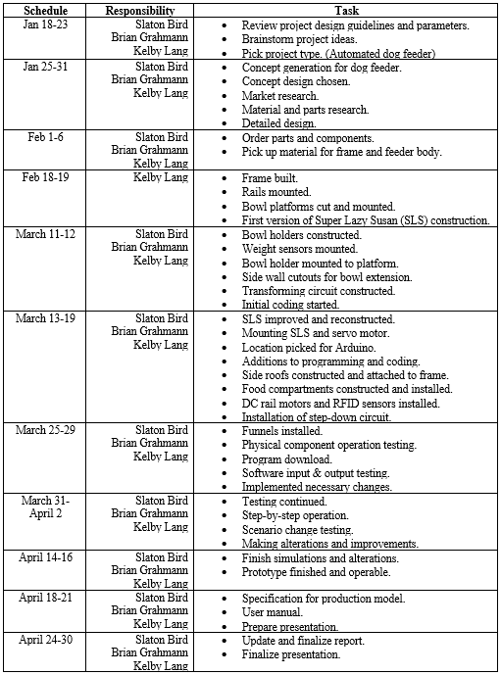

Figure 31 includes a detailed breakdown of the prototyping schedule for weeks one to eight.

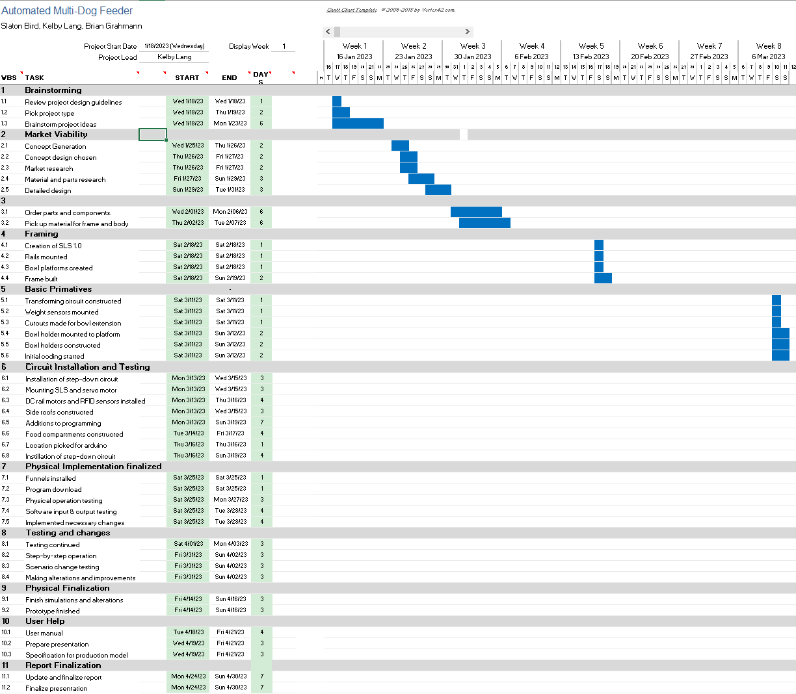

**Figure 31:** Gantt chart for week 1-8

Figure 32 includes a detailed breakdown of the prototyping schedule for weeks nine to sixteen.

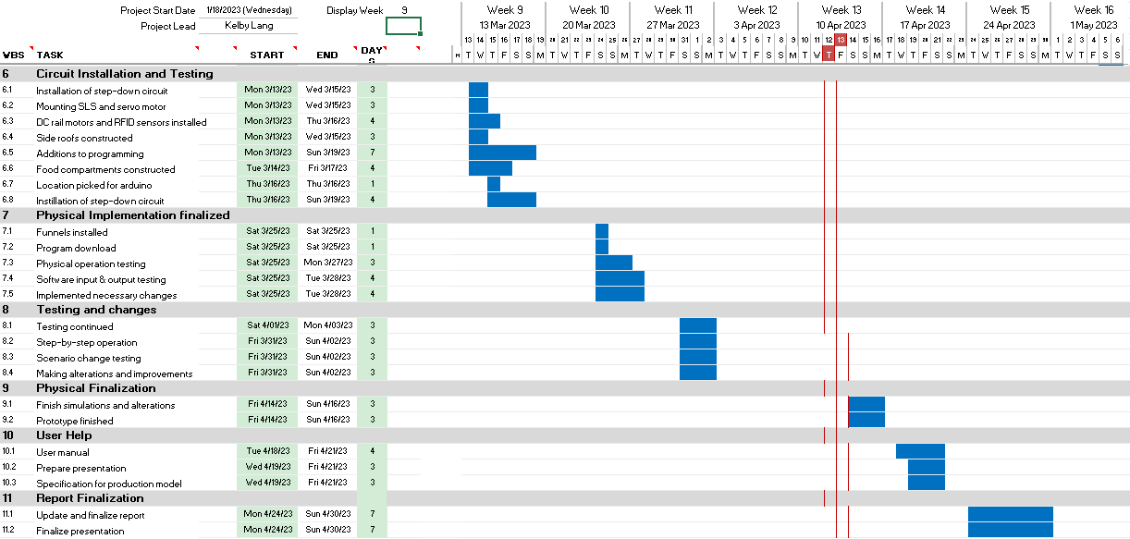

**Figure 32:** Gantt chart for week 9-16

Progression of Prototype:

Figure 33 features the preliminary construction of the feeder frame. The height of the frame was purposely assembled with extra length but would later be shortened after the food hopper was installed. The skeleton of the structure is comprised of two-by-four-inch pieces of wood and the base and walls are made from three-quarter-inch plywood. After the height was shortened the dimensions of the frame are as follows:

* Length: 22 in.
* Width: 22 in.
* Height: 35 in.

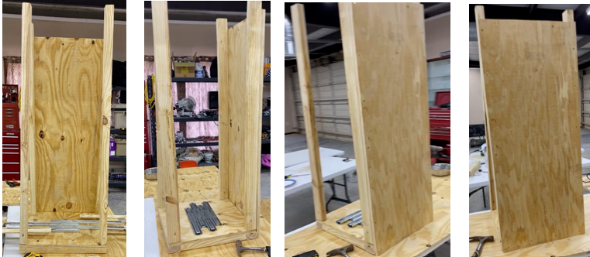

**Figure 33:** Front, side, and back view of feeder frame.

The assembly process of the food hopper is included in Figure 34. It was constructed using three-quarter-inch plywood. The bottom of the hopper consists of pieces of plywood that were attached to form a ninety-degree angle. The front and back walls were then cut and installed, and a divider was mounted in the middle of the hopper to form two feeding compartments. After mounting the sidewalls and testing the food volume of each compartment, the divider and side wall height was shortened. Each section can hold 1.8 gallons of kibble. Lastly, the hopper was mounted within the feeder frame.

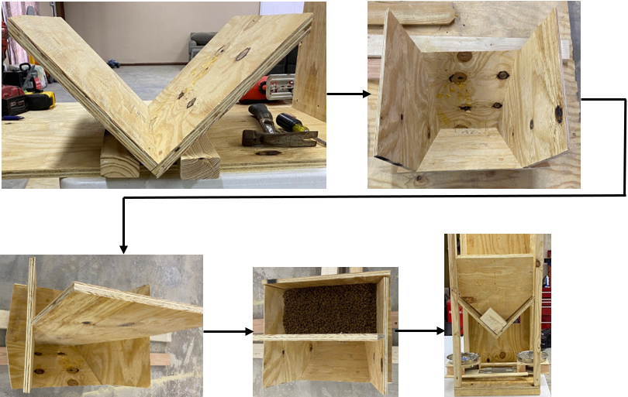

Volume Verification

Hopper Bottom

Hopper Bottom/ Font/Back Walls

Divider



**Figure 34:** Progression of food hopper.

The dimensions of the hopper base, sides, and food compartment divider are detailed in Figure 35. In order to ensure that each compartment could hold at least 1.8 gallons of kibble, the hopper was originally constructed with extra height. Once the compartment divider was installed, 2 gallons of dog food were poured into one of the compartments and the correct height dimensions were determined. The extra height was removed from the top portion of the hopper to the 2-gallon level ensuring that each compartment would house a minimum of 1.8 gallons of kibble.

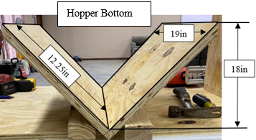 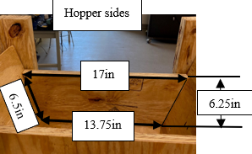

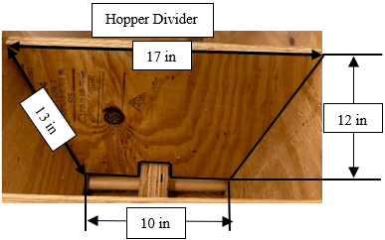

**Figure 35:** Dimensions of food hopper.

The SLS was fabricated using three-quarter-inch and one-quarter-inch plywood. Two five-and-a-half-inch diameter circles were cut out of the three-quarter-inch plywood and glued together. Calculations were done to pinpoint the volume needed for a quarter cup of food and the appropriate cutout was made on the SLS. Next, an additional two circles were constructed from quarter-inch plywood and glued to the sides of the SLS, completing the dispense holdings. A seven-eighth-inch hole was drilled in the center of the SLS for the wooden dowel drive shaft. After the appropriate holes were made in the food hopper, the drive shaft was inserted into the SLS and mounted to the hopper. The drive shaft was then attached to the servo motor. The complete construction process for the SLS is included in Figure 36.

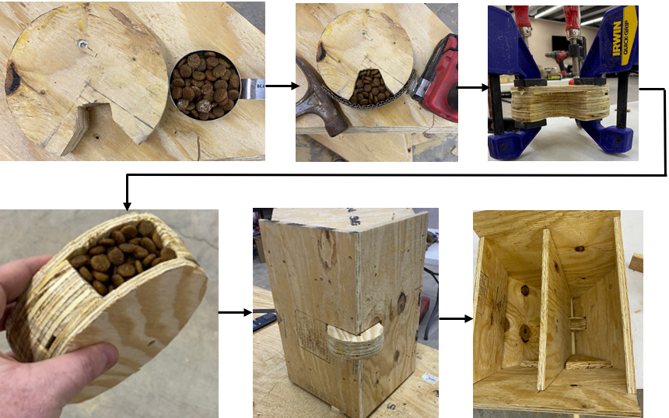



**Figure 36:** SLS Construction.

The dimensions of the SLS are detailed in Figure 37:

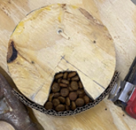 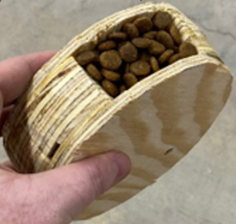

1.5in

3in

2in

5.5 in

**Figure 37:** SLS Construction.

The quarter-cup cutout in the SLS is a trapezoidal pyramid shape. The base and length dimensions were dictated by the size of the SLS as the cutout had to fit within a 90-degree section of the dispenser. The following calculations were used to determine the dimensions and proper volume of a one-quarter cup and are featured in Figure 38:

* 1cup = 14.44in3
* V = ¼cup*(14.44in3 / 1cup) = **3.61in3**
* V = ½*(b1+b2)*H*L
* H = (2V) / [(b1+b2)*L]
  + = (2*3.61in3)/[(1in+3in)*1.5in] = **1.2in**

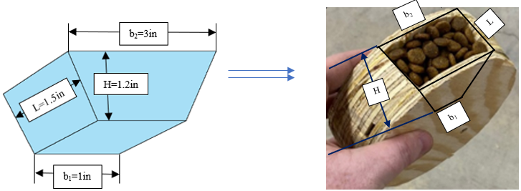

**Figure 38:** Trapezoidal cutout in SLS for ¼ cup volume.

The wooden dowel was used as the driveshaft and is controlled by a servo motor. As shown in Figure 39, the driveshaft is attached to the servo motor at the back of the food hopper. The other end is supported by and friction fit to a block of wood at the front of the hopper.

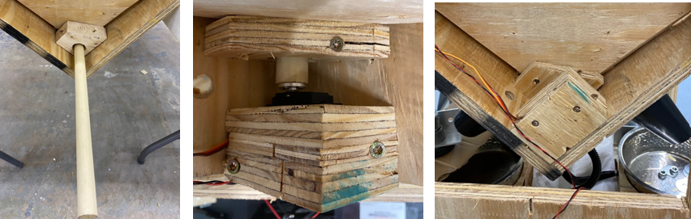

**Figure 39:** Servo motor and drive shaft.

The telescoping rails and bowl platforms are included in Figure 40. When fully retracted the rails are 14 inches in length and 27.5 inches when fully extended. The extension distance is 13.5 inches. Each tomahawk-shaped platform is attached to two rails. Shims were constructed out of quarter-inch plywood and installed between the platforms and the rails. This eliminated unwanted friction points from the system during bowl extension and retraction. The outside rails were eventually re-mounted directly below the narrow protrusions of the platforms to increase platform strength.

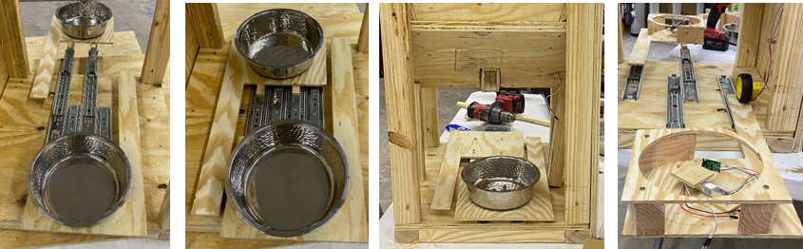

**Figure 40:** Railings and bowl platforms.

The positioning dimensions of the railings and bowl platforms are shown in Figure 41:

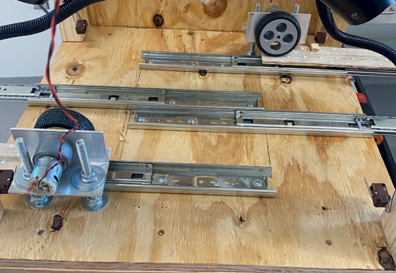 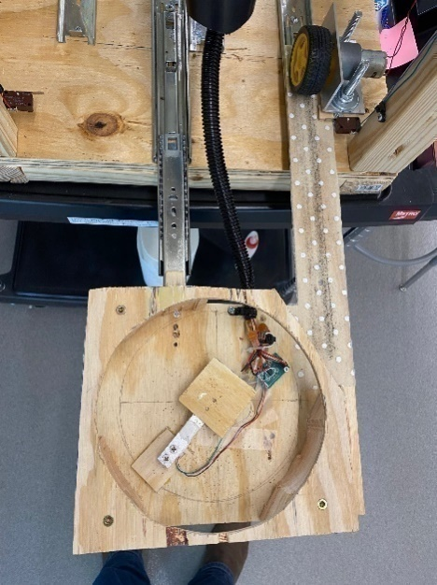

7.75in

12.25in

20.25in

8in

10in

3.75in

2.5in

2.5in

4in

**Figure 41:** Railings and bowl platforms.

Figure 42 features the mounting steps for the weight sensors. A small piece of quarter-inch plywood was first glued to the bowl platform. One end of the weight sensor was then mounted to it, with the other floating in the middle of the platform. An additional square section of quarter-inch plywood was then fastened to the top of the floating end of the weight sensor. In this manner, the food bowls sit centered on the floating part of the sensor for optimal weight measuring.

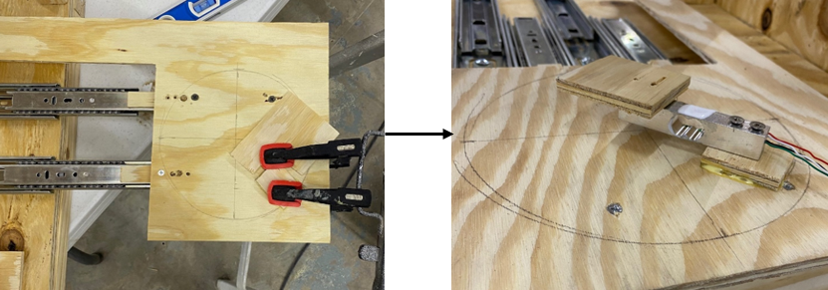

**Figure 42:** Mounting weight sensors.

The assembly process for the bowl holders is shown in Figure 43. They were constructed using a combination of quarter-inch plywood and two-by-fours. The hole diameter is 7.25 inches, which allows the bowls to sit directly on the weight sensors while still being secure.

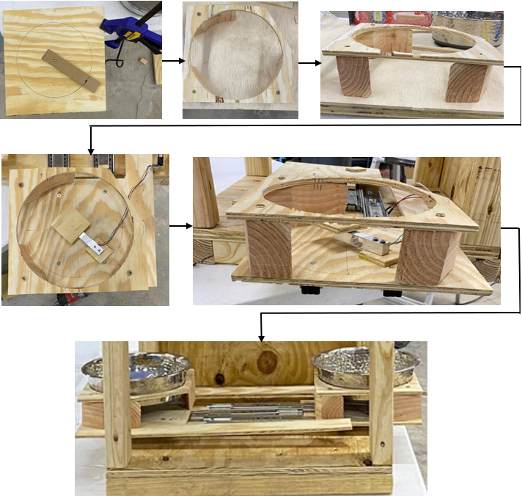

**Figure 43:** Bowl holder construction.

For securely mounting the DC motors and friction fitting the wheels to the platform protrusions, aluminum L-shaped channels were used. After securing the motors to the channels, two 3/8-inch holes were drilled in each channel, as well as in the base of the feeder. Using 3/8-inch by 4.5-inch carriage bolts the motors were mounted to the base of the feeder. Nuts and washers were used to apply the optimal pressure of the wheels to the platform protrusions. This is shown in Figure 44.

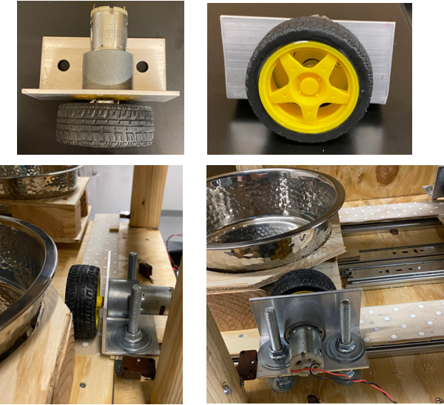

**Figure 44:** DC motor and wheel mounting.

Shown in figure 45, within the prototype we used momentary contact switches, like one would find in a microwave, as limit switches. There are two switches on each track of the bowl. One switch checks for the open status of the drawer, while the other checks for close status of the drawer. This allows for the system to check if the drawer is stuck and set changes accordingly. This is an extremely necessary step in the prototype, as it’s a safety measure to ensure no animal gets seriously injured in they happen to somehow get stuck in the drawer while movement mechanism is in operation. In the full production these components could be dropped entirely in favor of linear actuators that have limits built into them.

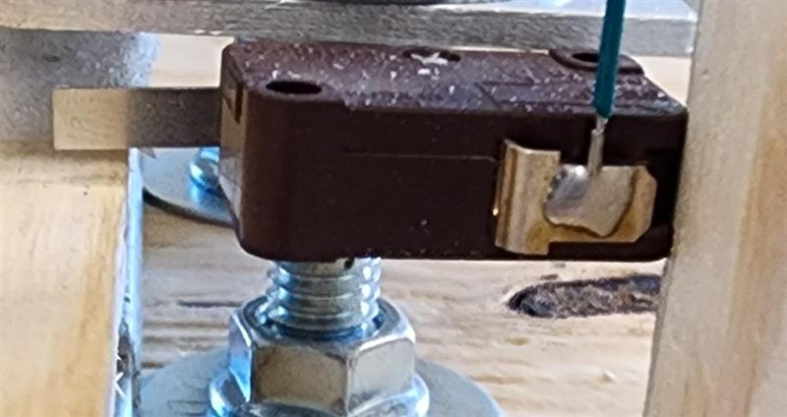

**Figure 45:** Momentary contact switches.

With the bowls secured in their proper positions, the dispensing funnel locations were able to be determined. The funnel holder was fabricated out of quarter-inch plywood and one-by-two-inch pieces of wood and is shown in Figure 46. After gluing the funnels to their housing units, each unit was attached to the base of the hopper, with the top of the funnels centered under the SLS dispensing locations and the bottom of the funnels centered over the food bowls.

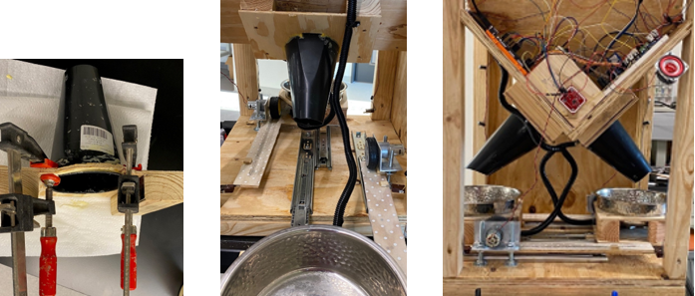

**Figure 46:** Funnel construction and mounting.

RFID sensors that were easily obtainable given the time restrictions were incapable of detecting tags beyond roughly 1 cm, despite being rated for up to 1 m. In the prototype these weaker sensors were used to show proper functionality and interactivity with written code, these are shown in figure 47. In the full product, battery powered active sensors and RFID antennas will be selected to better achieve the intended goals of the projects design.

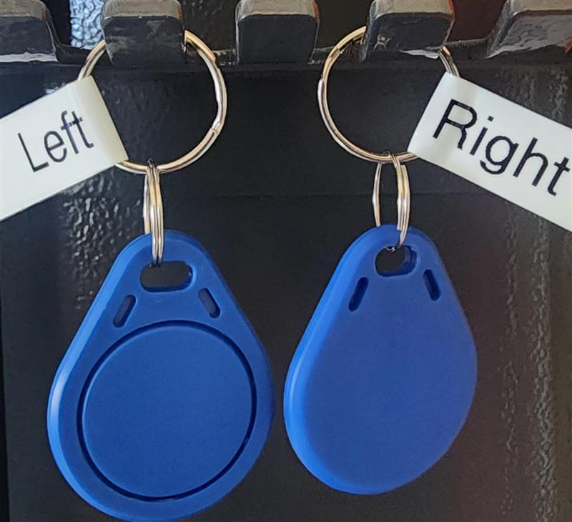 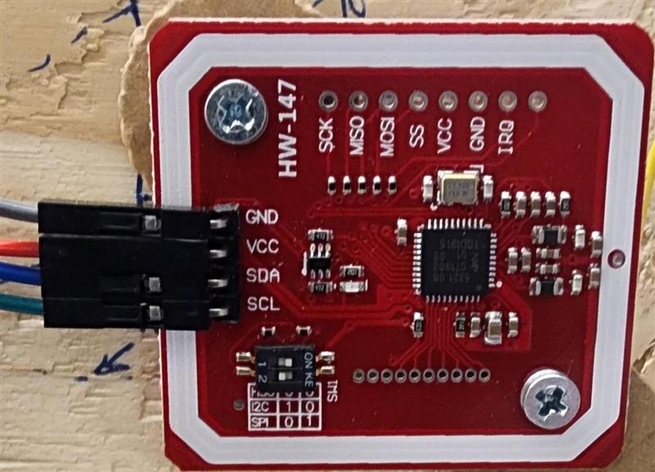

**Figure 47:** Prototype RFID tags and sensor.

Audio output was achieved by saving .wav files to a micro-SD card and outputting the file to a digital PWM signal using the Arduino library TMRpcm **[30]**. This output was amplified using the simple common emitter amplifier in Figure 48. The TIP121G Darling power transistor was used for this circuit as it was available at the time **[36]**. The signal was fed through a speaker represented by the inductor in Figure 48. A Back horn speaker box was designed in SolidWorks to fit the speaker and 3d printed to further amplify the audio.

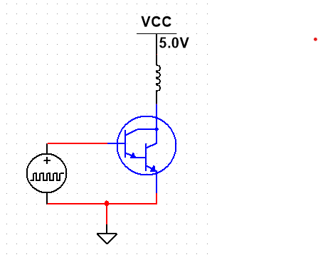

**Figure 48:** Darlington Pair current amplifier for speaker

Figure 49 includes every electrical component of the dog feeder. A detailed wiring diagram for the entire system is provided in Appendix A. The wiring between the battery and the fuse is 16 American Wire Gauge (AWG) in size; all other system wiring is done using 22 AWG wires chosen for their availability and compatibility with the breadboards and Arduino connectors.

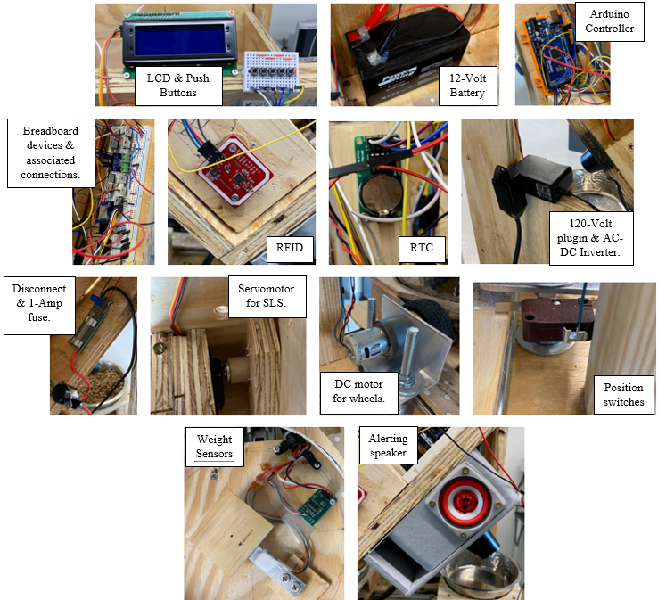 **Figure 49** Prototype wiring and electrical components.

The feeder requires a 120-Volt AC plug-in currently provided by an extension cord and commercial battery trickle charger which converts the mains voltage to a nominal 12-Volt DC, to maintain the charge of the battery. The 12-Volt output from the battery runs through a 1-amp fuse and a disconnect switch. The inward side of the breadboard distributes 12-Volt nominal voltage directly from the battery, only the motor drivers for the platforms run directly from the battery. 5-Volt and 7.5-Volt levels are supplied by linear voltage regulators L7805CV and L78S75CV **[34, 35].** Only the SLS servo motor operates on 7.5 Volts and almost all remaining circuits operate on 5 volts, with only the RFID antenna having 3.3 Volts provided by the Arduino. The user interface LCD is operated using an I2C interface and a standard Arduino Software library. The 5 user interface buttons and 4 limit switches each connect a digital pin with an internal pull-up in the Arduino to ground when closed and are read by the change in voltage. The menu button specifically triggers an interrupt to launch the user interface. The two motors operating the feeding platforms are run by two H-bridges operating directly on battery voltage, two lower current H-bridges adapted from a commercial RC car board and used in lieu of MOSFET drivers that could not be procured in time serve to raise the voltage level from 5-Volt logic to battery voltage high enough to bring the MOSFETs into a full-on state. Under each bowl, a load cell is wired to an HX711 Analog to Digital Converter that communicates to the Arduino through Software I2C **[39]**. In addition, a DS1302 Real Time Clock is connected using Serial Peripheral Interface, and the SLS Servo motor is connected to a single wire PWM output, both are operated using Arduino standard libraries **[40]**.

The fully operating prototype was attached to a Keysight E36311A DC power supply and Keysight BenchVue Software to measure power draw. Total energy consumption for a maximum feeding cycle was measured at approximately 1.8 x 10­­­-6-Watt hours giving us a total energy consumption of 50 x 10­­­-5-Watt hours for a full week’s 28 feeding cycles which is negligible compared to the available battery life. However, standby power draw averaged over a 25-minute test was found to be 1.36 Watts, which would consume approximately 228-Watt hours in a 168-hour week or 19.04 Ampere hours on a 12 Volt nominal battery, this would require the parallel combination of 3 the currently specified 7 Ampere hour battery or a higher capacity battery of different chemistry. Extension of battery life would be better achieved through the reduction of standby power which is further expanded on in future work.

The completed prototype is featured in Figure 50. A user manual for the system is included in Appendix B.

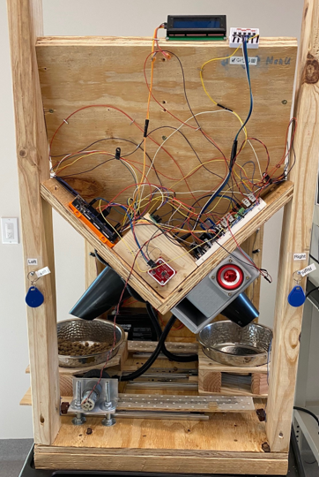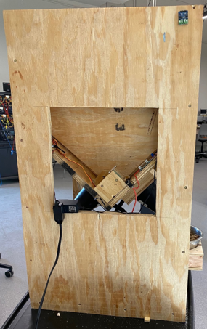

Front

Back

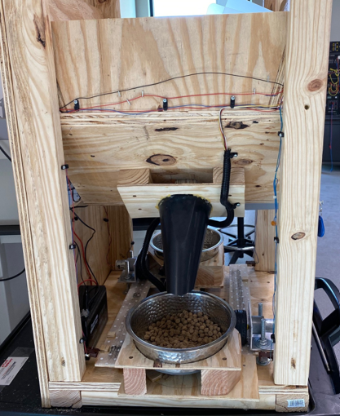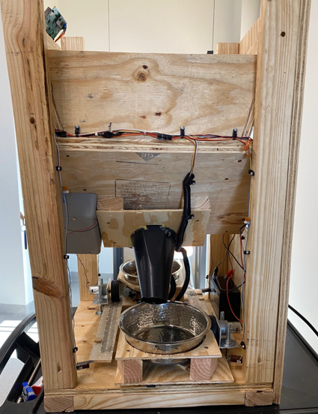

Left Side

Right Side

**Figure 50:** Front, back, left-side, and right-side views of completed prototype.

**Testing Verification:**

Eight formal tests of the prototype were conducted and are shown in Figure 51. The Mechanical, Motor Software, User Interface, and Software Settings unit tests individually verify the function of component parts of the total system after development. After preliminary testing, the motor software was further developed to interface with all sensors. All of the components were then tested in two steps as they were integrated into the main mechanical and software sections before performing an all up Operational Test of the final prototype.

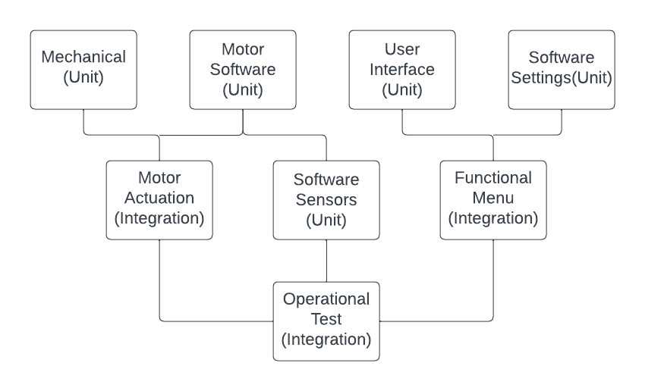

**Figure 51:** Testing and Integration Plan. *Created with Lucidchart.*

The Mechanical Unit Test, as shown in Figure 52, was performed upon completing the construction of the primary housing and mechanical portions of the feeding platforms and SLS. This test ensures that the feeding platforms and SLS function as intended and are capable of supporting the forces involved while moving smoothly enough to be operated by microcontroller-controlled motors. The procedure also includes a measurement of the torque required to turn the SLS so that the requirements of the production servo motor can be assessed. It was found that the railings and platform operated smoothly, but there were friction points between the SLS and the food hopper base.

|  |  |  |  |  |  |  |  |  |
| --- | --- | --- | --- | --- | --- | --- | --- | --- |
| **Test Writer:** Brian Grahmann | | | | | | | | |
|  | **Test Case Name:** | Mechanical Unit Test | | | | | **Test ID #:** | Mech(U) |
|  | **Description:** | Checks that the mechanical construction functions as intended | | | | | **Type:** | þ white box |
| o black box |
| **Tester Information** | | | | | | | | |
|  | **Name of Tester:** | Kelby Lang | | | | | **Date:** | 3/14/2023 |
|  | **Hardware Ver:** | Automated Dog Feeder | | | | | **Time:** | 9:00 a.m. |
|  | **Setup:** | All non-powered mechanical portions should be assembled. Feeding platforms should be attached to bearing supports and supporting simulated weight. SLS should be in place. Test kibble should be loaded in hoppers. | | | | | | |
| **Step** | **Action** | **Expected Result** | **Pass** | **Fail** | **N/A** | **Comments** | | |
| 1 | Manually slide feeding platforms in and out through interaction with rack extensions. | Feeding platforms should slide smoothly without binding. | ü |  |  | Platforms extend and retract smoothly when pulled and pushed manually by hand. | | |
| 2 | Manually operate SLS from servo motor end. | SLS should move smoothly and dispense 1/4 cup of kibble per actuation. |  | ü |  | SLS does not rotate smoothly due to friction points between SLS and food hopper base. | | |
| 3 | Through use of SLS empty both hoppers. | Kibble should smoothly flow into SLS and empty completely. |  | ü |  | Unable to conduct test until ridding system of friction points. | | |
| 4 | With SLS positioned in furthest up position, attach to a measured torque arm and suspend weights. | Required SLS torque can be measured by calculating the torque at which the SLS first moved. |  | ü |  | Due to the SLS and drive shaft being directly supported by the servomotor this test could not be completed. | | |
|  | **Overall test result:** | |  | ü |  | Remove friction points. Redo test. | | |

**Figure 52:** First Mechanical Unit Test. *Created with Microsoft Excel.*

After removing the friction points the same mechanical unit test, included in Figure 53, was performed. The rotation and dumping capabilities operated correctly at this point. The torque test was unable to be performed due to the drive shaft and SLS being directly supported by the servomotor. In a redesigned production model bearings would be used to support the dispensing components, which would allow for reducing the torque on the servomotor under full load.

|  |  |  |  |  |  |  |  |  |
| --- | --- | --- | --- | --- | --- | --- | --- | --- |
| **Test Writer:** Brian Grahmann | | | | | | | | |
|  | **Test Case Name:** | Mechanical Unit Test | | | | | **Test ID #:** | Mech(U) |
|  | **Description:** | Checks that the mechanical construction functions as intended | | | | | **Type:** | þ white box |
| o black box |
| **Tester Information** | | | | | | | | |
|  | **Name of Tester:** | Kelby Lang | | | | | **Date:** | 3/14/2023 |
|  | **Hardware Ver:** | Automated Dog Feeder | | | | | **Time:** | 12:00 p.m. |
|  | **Setup:** | All non-powered mechanical portions should be assembled. Feeding platforms should be attached to bearing supports and supporting simulated weight. SLS should be in place. Test kibble should be loaded in hoppers. | | | | | | |
| **Step** | **Action** | **Expected Result** | **Pass** | **Fail** | **N/A** | **Comments** | | |
| 1 | Manually slide feeding platforms in and out through interaction with rack extensions. | Feeding platforms should slide smoothly without binding. | ü |  |  | Platforms extend and retract smoothly when pulled and pushed manually by hand. | | |
| 2 | Manually operate SLS from servo motor end. | SLS should move smoothly and dispense 1/4 cup of kibble per actuation. | ü |  |  | SLS does rotates smoothly and dumps 1/4 cup of food when spun manually by hand. | | |
| 3 | Through use of SLS empty both hoppers. | Kibble should smoothly flow into SLS and empty completely. | ü |  |  | SLS empties both compartments when spun manually by hand. | | |
| 4 | With SLS positioned if furthest up position, attach to a measured torque arm and suspend weights. | Required SLS torque can be measured by calculating the torque at which the SLS first moved. | ü |  |  | Servo motor torque is sufficient in dispensing food when both compartments are full. | | |
|  | **Overall test result:** | | ü |  |  | Successful test. | | |

**Figure 53:** Second Mechanical Unit Test. *Created with Microsoft Excel.*

The Software Motor unit test, shown in Figure 54, was performed upon completion of the DC motor driver circuits and code for both the DC motors and servomotor. This test verifies that the software and driver circuits are capable of operating the DC motors in both directions and positioning the servo motor as needed to actuate the SLS. It was determined that the DC motors and wheels successfully moved the platforms in and out of the feeder when running the program. The same results were yielded with the functioning of the servomotor, drive shaft, and SLS.



**Figure 54:** Software Motor Unit Test. *Created with Microsoft Excel.*

The Motor Actuation Integration test, featured in Figure 55, was performed after the DC motors and servo motor were attached to the mechanical portion of the prototype. This test verified that the motors, driver circuits, and software smoothly operated the SLS and feeding platforms. The results of this test were meant to determine if modifications must be made to run the motors with PWM or at a higher supply voltage. It was decided that PWM would not be used as the motors functioned adequately using the voltage supplied from the H-bridge circuit. It was found that the motors and mechanical construction interacted as designed.

|  |  |  |  |  |  |  |  |  |
| --- | --- | --- | --- | --- | --- | --- | --- | --- |
| **Test Writer:** Brian Grahmann | | | | | | | | |
|  | **Test Case Name:** | Motor Actuation Integration | | | | | **Test ID #:** | Motors(I) |
|  | **Description:** | Checks that the motors and mechanical construction interact as designed. | | | | | **Type:** | þ white box |
| o black box |
| **Tester Information** | | | | | | | | |
|  | **Name of Tester:** | Kelby Lang | | | | | **Date:** | 3/18/2023 |
|  | **Hardware Ver:** | Automated Dog Feeder | | | | | **Time:** | 11:00 a.m. |
|  | **Setup:** | DC motors and drive wheels should be installed in feeder driver circuits should be wired to DC motors and battery. Servomotor should be attached to SLS and wired to microcontroller. After step 1 driver circuits should be wired to microcontroller. | | | | | | |
| **Step** | **Action** | **Expected Result** | **Pass** | **Fail** | **N/A** | **Comments** | | |
| 1 | Apply 5 v to Open and Close inputs of motor drivers | DC motors should open and close feeding platforms. | ü |  |  | Platforms successfully extend and retract. | | |
| 2 | Call Left and Right Platform open and close functions. | DC motors should open and close feeding platforms. | ü |  |  | Platforms successfully extend and retract. | | |
| 3 | Call SLS Idle function | Servo motor should move SLS to center idle position. | ü |  |  | Servo motor operated as intended. | | |
| 4 | Call SLS right Actuation Function. | SLS should dispense 1/4 cup of kibble into right bowl. | ü |  |  | Servo motor operated as intended. | | |
| 5 | Call SLS Left Actuation Function | SLS should dispense 1/4 cup of kibble into left bowl. | ü |  |  | Servo motor operated as intended. | | |
|  | **Overall test result:** | | ü |  |  | Successful test. | | |

**Figure 55:** Motor Actuation Integration Test. *Created with Microsoft Excel.*

The Software Sensors Unit test, included in Figure 56, was performed upon completion of the software to read the weight sensors, RFID, and feeding platform position microswitches. This test verified the functionality of all sensors and related software before integrating them into the prototype. The test results were successful.

|  |  |  |  |  |  |  |  |  |
| --- | --- | --- | --- | --- | --- | --- | --- | --- |
| **Test Writer:** Brian Grahmann | | | | | | | | |
|  | **Test Case Name:** | Software Sensors Unit | | | | | **Test ID #:** | Sensors(U) |
|  | **Description:** | Checks that software can read values from sensors. | | | | | **Type:** | þ white box |
| o black box |
| **Tester Information** | | | | | | | | |
|  | **Name of Tester:** | Brian Grahmann & Slaton Bird. | | | | | **Date:** | 3/25/2023 |
|  | **Hardware Ver:** | Automated Dog Feeder | | | | | **Time:** | 2:00 p.m. |
|  | **Setup:** | Weight, microswitch, and RFID sensors should be wired to microcontroller and developed functions and test script installed. Weight sensors should be attached to a testing platform. | | | | | | |
| **Step** | **Action** | **Expected Result** | **Pass** | **Fail** | **N/A** | **Comments** | | |
| 1 | Place known weight on each weight sensor and query weight. | Measured weight should be accurate within weight of 1/4 cup of testing kibble. | ü |  |  | Weight measurement was accurate. | | |
| 2 | Manually press each microswitch. | Software serial output should register all switch presses. | ü |  |  | Software serial output was registered for all switches. | | |
| 3 | Place RFID tags close to sensors. | Software output should register read of RFID tags individually. Detection range should be at least 40cm. | ü |  |  | RFID successfully read. | | |
|  | **Overall test result:** | | ü |  |  | Successful test. | | |

**Figure 56:** Software Sensors Unit Test. *Created with Microsoft Excel.*

The User Interface Unit Test, shown in Figure 57, tests the user interface buttons and LCD for menu navigation and the ability to call the functions to set time and feeding schedules. Placeholder functions are used to make serial output calls to verify that the selected functions are being called. Test results were successfully.

|  |  |  |  |  |  |  |  |  |
| --- | --- | --- | --- | --- | --- | --- | --- | --- |
| **Test Writer:** Brian Grahmann | | | | | | | | |
|  | **Test Case Name:** | User Interface Unit Test | | | | | **Test ID #:** | UI(U) |
|  | **Description:** | Checks that the user interface functions as intended | | | | | **Type:** | þ white box |
| o black box |
| **Tester Information** | | | | | | | | |
|  | **Name of Tester:** | Brian Grahmann & Slaton Bird | | | | | **Date:** | 3/27/2023 |
|  | **Hardware Ver:** | Automated Dog Feeder | | | | | **Time:** | 9:00 a.m. |
|  | **Setup:** | LCD and user interface buttons should be wired to microcontroller. Microcontroller should have user interface software installed with placeholder testing functions. | | | | | | |
| **Step** | **Action** | **Expected Result** | **Pass** | **Fail** | **N/A** | **Comments** | | |
| 1 | Press "Menu" button | Menu Interrupt should be called and menu appear on LCD. | ü |  |  | Menu appeared on screen. | | |
| 2 | Press "Up" and "Down" buttons | Buttons should navigate up and down through menu displayed on LCD | ü |  |  | Up and down buttons worked. | | |
| 3 | Press "Enter" Button | Indicated menu option should be opened. | ü |  |  | Menu options opened. | | |
| 4 | Press "Back" button | Menu should return to previous screen. | ü |  |  | Back button worked. | | |
| 5 | Navigate through menu using buttons. | Menu navigation should match designed menu tree. | ü |  |  | Menu navigation matched menu tree. | | |
| 6 | Attempt to adjust settings with menu. | Software serial output should register placeholder function calls. | ü |  |  | Menu settings adjusted properly. | | |
|  | **Overall test result:** | | ü |  |  | Successful Test. | | |

**Figure 57:** User Interface Unit Test. *Created with Microsoft Excel.*

The Software Settings Unit Test, included in Figure 58, verified that the functions, to be called by the user interface, properly set the time on the RTC, and wrote the feeding schedule to the Electronically Erasable Programmable Read-Only Memory (EEPROM). This test also verified that the user selected feeding settings and current time were retained in EEPROM and the RTC during loss of power events and that the software can recover and resume operation.

|  |  |  |  |  |  |  |  |  |
| --- | --- | --- | --- | --- | --- | --- | --- | --- |
| **Test Writer:** Brian Grahmann | | | | | | | | |
|  | **Test Case Name:** | Software Settings Unit Test | | | | | **Test ID #:** | Settings(U) |
|  | **Description:** | Checks that software functions are capable of placing user selected settings in RTC and EEPROM and reading these settings. | | | | | **Type:** | þ white box |
| o black box |
| **Tester Information** | | | | | | | | |
|  | **Name of Tester:** | Brian Grahmann & Slaton Bird | | | | | **Date:** | 3/31/2023 |
|  | **Hardware Ver:** | Automated Dog Feeder | | | | | **Time:** | 10:00 a.m. |
|  | **Setup:** | Setting interface functions should be programmed in microcontroller. Test script will be used to call functions. | | | | | | |
| **Step** | **Action** | **Expected Result** | **Pass** | **Fail** | **N/A** | **Comments** | | |
| 1 | Call RTC setting function with current time, wait 1 min. and call RTC output function. | RTC should return the current time. | ü |  |  | RTC returned to current time. | | |
| 2 | Call all 4 feeding time setting functions with simulated inputs, cycle power on microcontroller and call feeding time query functions. | The settings entered should be retained in EEPROM and returned after power cycle. | ü |  |  | Entered settings were retained in EEPROM and returned after power cycling. | | |
|  | **Overall test result:** | | ü |  |  | Successful test. | | |

**Figure 58:** Software Settings Unit Test. *Created with Microsoft Excel.*

The Functional Menu Integration test, shown in Figure 59, was performed after the User Interface (UI) and software settings had been combined into the full scheduling and control portion of the software. This test verified that the user interface interacted with the software settings as intended and that the user is capable of controlling all device functions through only the use of the five supplied buttons and feedback from the LCD.

|  |  |  |  |  |  |  |  |  |
| --- | --- | --- | --- | --- | --- | --- | --- | --- |
| **Test Writer:** Brian Grahmann | | | | | | | | |
|  | **Test Case Name:** | Functional Menu Integration Test | | | | | **Test ID #:** | UI(I) |
|  | **Description:** | Checks that the user interface can set software settings as intended. | | | | | **Type:** | þ white box |
| o black box |
| **Tester Information** | | | | | | | | |
|  | **Name of Tester:** | Brian Grahmann & Slaton Bird | | | | | **Date:** | 4/14/2023 |
|  | **Hardware Ver:** | Automated Dog Feeder | | | | | **Time:** | 11:00 a.m. |
|  | **Setup:** | User interface LCD and buttons should be wired to microcontroller all setting functions should be fully programmed in UI. Testing script should read all settings to serial output. | | | | | | |
| **Step** | **Action** | **Expected Result** | **Pass** | **Fail** | **N/A** | **Comments** | | |
| 1 | Set Clock using user interface and exit menu. | Idle screen should show current time. | ü |  |  | Current time was shown. | | |
| 2 | Set Simulated feeding schedule through use of user interface and run test script. Repeat with different schedule. | Test Script should return the most recently programmed schedule. | ü |  |  | Programmed schedule was returned. | | |
| 3 | Cycle power to microcontroller and run test script. | After power cycle previous settings should still read out. Clock should still be accurate to current time. | ü |  |  | Previous settings read out. Clock showed correct time. | | |
|  | **Overall test result:** | | ü |  |  | Test successful. | | |

**Figure 59:** Functional Menu Integration Test. *Created with Microsoft Excel.*

The Operational Integration Test, included in Figure 60, is the first all-up test of the prototype.

This test was performed after all other units were built, tested, and integrated into version 1.0 of the prototype. This test verifies the function of the full prototype and will identify any need for modification in the final design.

|  |  |  |  |  |  |  |  |  |
| --- | --- | --- | --- | --- | --- | --- | --- | --- |
| **Test Writer:** Brian Grahmann | | | | | | | | |
|  | **Test Case Name:** | Operational Integration Test | | | | | **Test ID #:** | Function(I) |
|  | **Description:** |  | | | | | **Type:** | þ white box |
| o black box |
| **Tester Information** | | | | | | | | |
|  | **Name of Tester:** | Brian Grahmann & Slaton Bird | | | | | **Date:** | 4/16/2023 |
|  | **Hardware Ver:** | Automated Dog Feeder | | | | | **Time:** | 1:00 p.m. |
|  | **Setup:** | Feeder should be fully assembled, Version 1.0 software should be installed on microcontroller with serial test output print statements. | | | | | | |
| **Step** | **Action** | **Expected Result** | **Pass** | **Fail** | **N/A** | **Comments** | | |
| 1 | Set Clock using UI | Idle display should show current time. | ü |  |  | Correct time shown. | | |
| 2 | Set feeding schedules to the next 10 minute intervals. | Serial output should show set schedules. | ü |  |  | Set schedule appeared. | | |
| 3 | Cycle power to microcontroller | Serial output should show set schedules. | ü |  |  | Set schedule appeared. | | |
| 4 | Wait. | Programmed Feeding Schedules should actuate on time. | ü |  |  | Feeding happened at correct time. | | |
| 5 | When Feeding schedule actuates bring RFID near feeder. | Platforms should open when RFID detected. | ü |  |  | Platforms opened on RFID detection. | | |
| 6 | After all 4 feeding schedules actuate bring individual RFID close. | Associated platforms should open. | ü |  |  | Correct platform opened. | | |
| 7 | Set option to feed both dogs simultaneously and bring both RFIDs close. | Both platforms should open. | ü |  |  | Both platforms opened. | | |
| 8 | Set option to NOT feed both dogs simultaneously and bring both RFIDs close. | No platforms should open | ü |  |  | Platforms stayed closed. | | |
|  | **Overall test result:** | | ü |  |  | Successful test. | | |

**Figure 60:** Operational Integration Test. *Created with Microsoft Excel.*

**Production Model Design:**

Following the completion of prototyping and testing, a production model was designed. The design team utilized the experience gained to determine the improvements needed from the prototype in the design of this model. All wooden components were changed to food-safe injection molded materials. The devices that were reused and components that kept their same dimensions from the prototype, while being made of a different material, are as follows:

* SLS.
* Servomotor.
* Battery.
* Arduino ATMEGA2560 (Could also be changed to equivalent microcontrollers)
* Rails.
* Bowl holders.
* Weight sensors.

It was determined that the DC motorized wheel, used for food bowl extension and retraction in the prototype, needed to be replaced. The two solutions that were most applicable were either a rack and pinion or a linear actuator, shown in Figure 61**[27, 28]**.

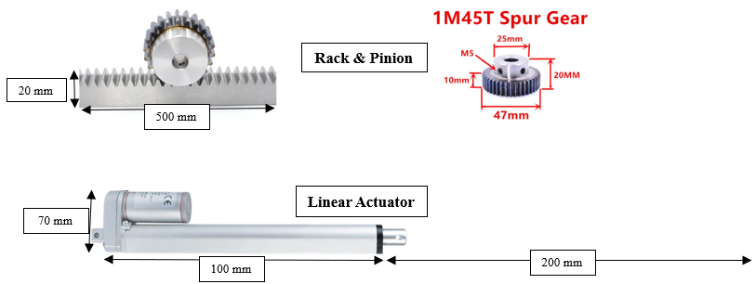

**Figure 61:** Dimensions of rack and pinion and linear actuator.

The rack and pinion would require less redesign in the bowl platforms and frame dimensions, but ultimately it was decided to use the linear actuator to eliminate possible jamming or stalling. The rack and pinion may get dust or other particles stuck in its spur gear or track over time. Additionally, using the rack and pinion means that the tomahawk-shaped handle portion of the bowl platforms would still be implemented. This was a major point of weakness in the prototype. It is difficult to support the narrow floating track, due to its flimsiness. Over time this part of the system would cause problems with the extension and retraction system. Linear actuators provide an improved functionality design for moving the load in a linear motion back and forth. Furthermore, by choosing linear actuators, the need for momentary contact position switches became redundant, which minimizes the devices required for system operations.

Next, all remaining components involving the movement of the bowls and anything that would be mounted to the base of the feeder were selected and laid out. This included the rails, bowl platforms and holders, weight sensors, two-linear actuators, and the battery. The same battery and rails from the prototype are to be used in the production model. The DC motors were replaced by linear actuators and the tomahawk-handle portion of the platforms was removed, making the platform dimensions 8 by 8 inches. The system components to be mounted on the feeder base are shown in Figure 62.

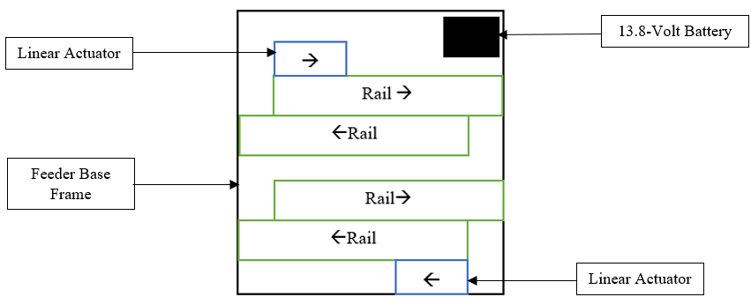

**Figure 62:** Top view of component layout of feeder base for production model.

The component layout on the base of the feeder determined the dimensions of the base as shown in Figure 63.

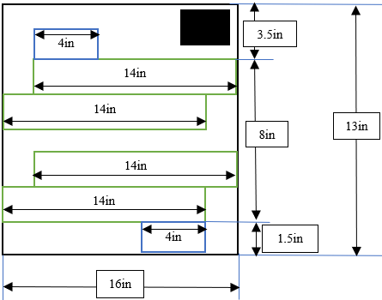

**Figure 63:** Top view of component and feeder base dimensions for production model.

After the layout was completed, it was determined that the feeder base was 16 by 13 inches. This dictated the length and width of the dog feeder structure. Next, to calculate the height of the feeder, the food hopper dimensions needed to be specified. The hopper was re-designed using an upside-down rectangular pyramid which is shown in Figure 64. The rectangular base of the hopper has a length of 6.75 inches. This accounts for the three-quarter-inch divider in the middle of the hopper, as well as the 3-inch opening of the SLS. The rectangular base of the hopper has a width of 2 inches to match the SLS width. In this way, the hollow bottom of the hopper allows the opening of the SLS dispenser to sit precisely where it needs to be when serving each compartment. This ensures that the SLS seals the opening in the base of the hopper, preventing any leakage and preserving the dog food. The SLS drive shaft is no longer located within the bottom of the hopper as it was in the prototype. Instead, it is directly below the hopper, with approximately 4 inches of the SLS sticking below the food compartments. The top of the hopper matches the dimensions of the feeder frame of 16 by 13 inches.

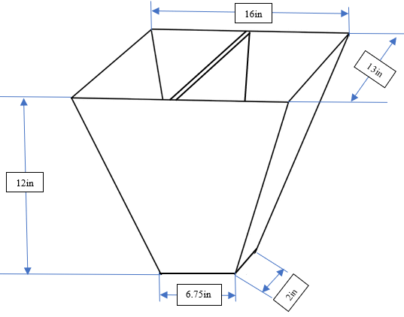

**Figure 64:** Food hopper dimensions for production model.

The volume of the food hopper was determined by calculating the volume of two rectangular pyramids, one small one and one large one. The volume of the smaller pyramid represents the bottom peak of the larger pyramid and was subtracted from the larger pyramid volume to determine the proper dimensions and food-holding volume of the hopper. The complete calculating process is as follows, including a visual representation in Figure 65. The final volume of the hopper is approximately 4 gallons which satisfy the condition of each compartment holding at least 1.8 gallons of kibble.

* 4gal = 924in3
* Select an overall volume of 940in3.
* Large pyramid:
  + V = 1/3*(l*w*h)
  + h = (3*V) / (l*w)
  + h = (3*940in3) / (16in*13in) **≈** **14in**
* Small pyramid:
  + h = (3*10in3) / (6.75in*2in) **≈** **2in**
* Total volume and height:
  + h = 14in - 2in = **12in**
  + V = 940in3 – 10in3 = **930in3 ≈** **4 gallons**

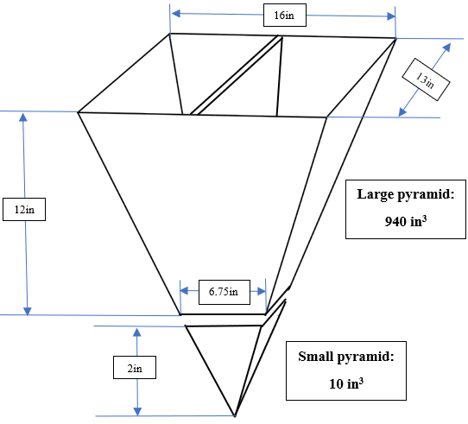

**Figure 65:** Food hopper volume, dimensioning, and calculations for production model.

Once the height of the food hopper was determined to be 12 inches, the height of the dog feeder frame was able to be calculated. The bowl platforms and funnel mount dimensions will be formed from injection molded materials, instead of wood. The bowl platforms have the same dimensions as in the prototype, excluding the tomahawk-shaped handles, but the funnels were shortened to be more economical in space.

The following dimensions were taken into consideration when calculating the overall height of the feeder:

* Hopper Height: 12in.
* Clearance needed for SLS, funnels, bowl holders and platforms, and rails: 8in.
* Total height of dog feeder: 12in + 8in = **20in.**

The dimensions of the feeder frame were determined to be 16 inches in length, 13 inches in width, and 20 inches in height. The last dimensioning to be done consisted of the overhanging roof structures to be mounted over the bowls where they extend out the sides of the feeder. The bowls’ top diameter is 8.5 inches, and the height of the bowls is 4.75 inches, therefore the width and height needed for the opening that they extend out of are 8.5 and 4.75 inches respectively. The rails extend 13.5 inches, so the length of the housing unit located above the extended bowls protrudes 5 inches out the side of the feeder frame. This allows just enough space for the bowls to be extended out of the feeder frame and be exposed during feeding time. A physical representation is included in Figure 66.

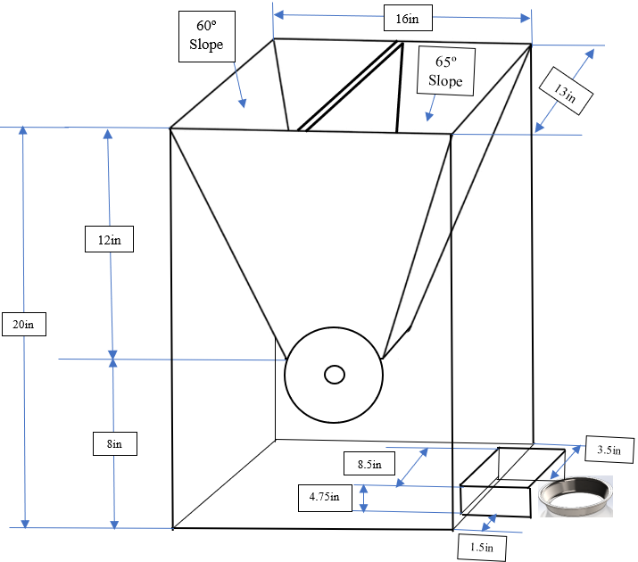

**Figure 66:** Frame and hopper dimensions of production model dog feeder.

The angles of the hopper walls were calculated using the dimensions of the large pyramid. The two sides walls of the hopper are 60-degree slopes, which was dictated by the equilateral triangular shape of the front and back walls of the hopper, as shown in Figure 67.

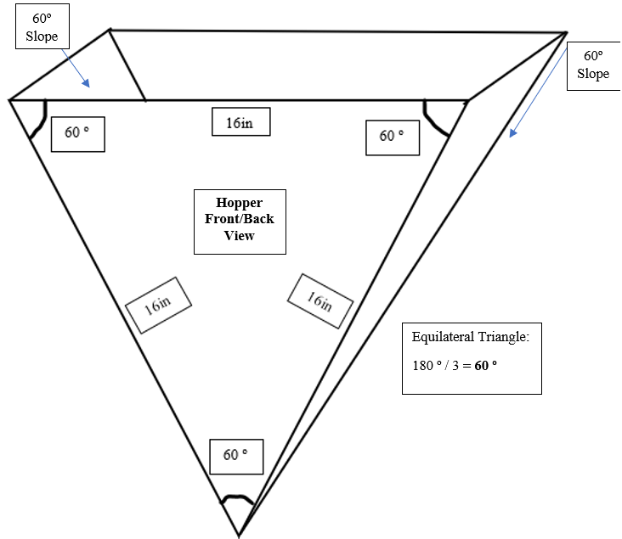

**Figure 67:** Figure and calculation of front and back walls of food hopper (used to find slope of side walls).

The front and back walls of the hopper were determined to be 65-degree slopes, which were dictated by the edge angles of the two sides of the hopper. The calculations and visual representation are shown in Figure 68. Slopes of 60 and 65 degrees ensure that the dog kibble will easily collect at the bottom of the hopper and not get stuck on any of the walls.

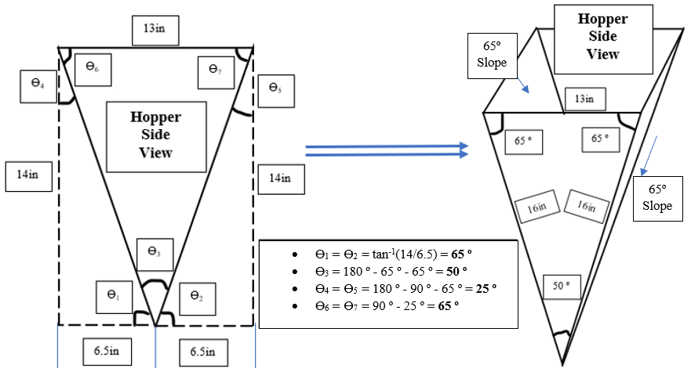

**Figure 68:** Figure and calculations for side walls of food hopper (used to find slope of front and back walls).

The final design makes use of higher-quality RFID sensors and active power NFC tags. This allows for the ranges of 1 to 2 meters of detection that were specified earlier in the design. The RFID system in the prototype offered only a minuscule range (roughly 1 cm). As a result, the prototype provided a valid proof of concept, but the RFID sensing capabilities caused a major flaw for the intended functionality goals. As shown in Figure 69, the active RFID tags, to be worn on the dogs’ collars, will be battery-powered so that they are always on, hence the active. While on, they can be detected by a single multi-antennae RFID sensor. This would slightly increase the cost per unit but would ultimately be necessary for the intended goal.

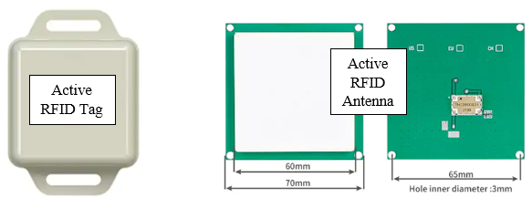

**Figure 69:** Active RFID tag & Antenna.

Injection Molding Process:

All of the components made out of wood in the prototype will need measurements to be sent out to a plastics company for injection molding. The injection molded plastics must be of high quality and made of food-safe material(s). Several plastics companies are possible avenues for production. The numbers presented in this report will be based on the information given by Pioneer Plastics**[27]**. For a large part (24+ inches) such as the feeder frame, the initial prototype could run north of $2,000. This implies the design would not need any changes to properly print. Any part that needs redesigning to functionally print will carry steep fees. However, after the injected molded feeder is finalized and is ready for upscaled productions in higher quantities the price significantly decreases to less than 5 dollars per unit. The injection molded process pays serious economic dividends at this point. The frame, supports, bowl platforms, weight sensor housing blocks, and sealed lid will all need to be printed as separate pieces. This is quite an expensive upfront cost but would significantly reduce the price of labor and time to develop a unit and is an absolute necessity for a mass-produced product.

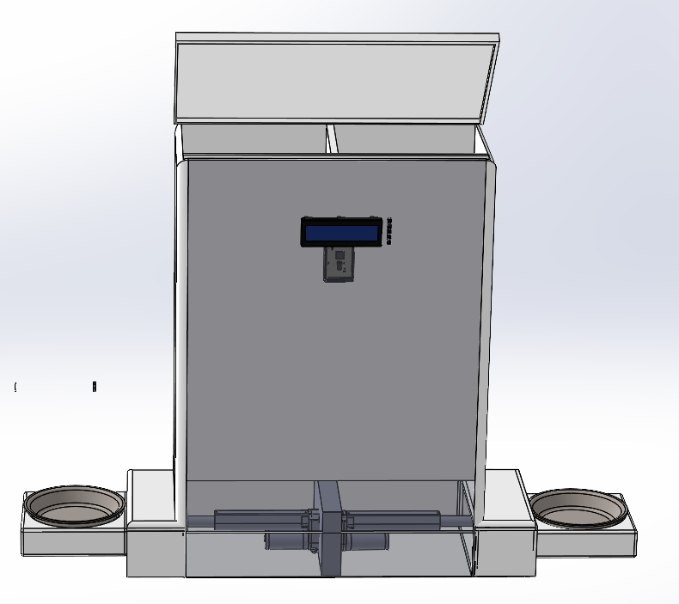

**Figure 70:** Final design for production model

The total BOM is below the allowable cost, but far above the intended design marginal production cost. Additional materials and suppliers will need to be researched to determine the most cost-effective parts and sources for a production model. In the time window given, it is not possible to give a proper estimate due to the time it takes to get injection molding. The final production model will use bulk-ordered parts which will drastically reduce the price per unit. As shown in Table 13, bulk prices for parts were configured using a unit order standard of 1000 units. The cost per unit of injection molding can be as low as $3, but the initial cost can be as high as $20,000 depending on the competency and complexity of the design. Active tags in the range desired could not be sourced. Any further production of this idea will need to design a more suitable active tag.

**Table 13:** Production Model Bill of Materials.

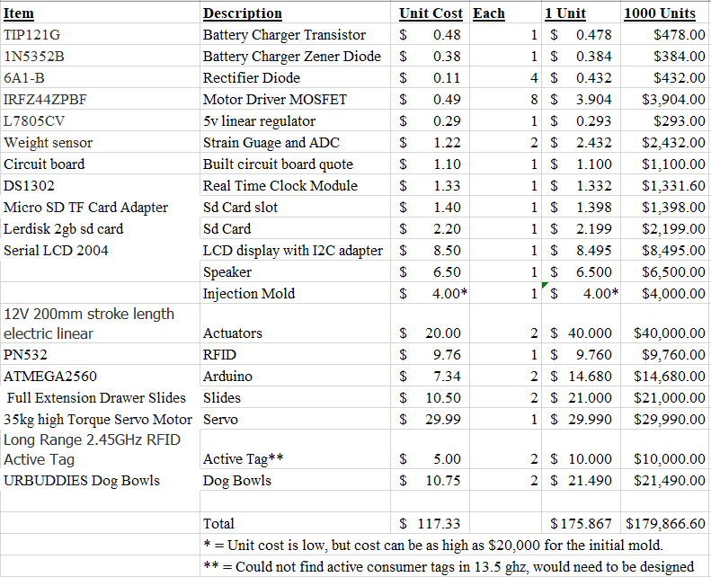

**Meeting Constraints:**

The production model was also designed based on the original design constraints that the automated dog feeder was intended to fulfill. The following list details how the constraints were met:

1. Size and capacity:

In the final design, the food storage volumes account for 1.8 gallons of kibble per pet. This is enough food storage to feed a 150-pound dog for a minimum of one week. Additionally, the dimensions of the feeder are 16 x 13 x 20 inches, allowing it to adequately fit against a wall in a home. The size and capacity of the feeder meet this design constraint.

1. Power source:

The power source for the apparatus is a 120-Volt 15-amp outlet, which is most commonly used in residential homes. There is also a 12-Volt battery back-up that will last up to a week in the loss of a power supply, which satisfies the power source constraint.

1. Operating voltages: The charging circuit is fed 120-Volt AC, in which a transformer and full bridge rectifier provide a DC power, and a Darlington transistor with its base clamped at 15 Volts by a Zener diode provides a charging current.

12 volt = Platform motors, 7.5 volt = SLS, 5 volt = everything else 3.3 volt = RFID

1. Operating currents: Operating currents of the prototype were well within the capabilities of both the standard outlet and chosen wiring. Full operation was possible through a 1 Ampere fuse and is expected to be much lower in the re-designed model.
2. Dispensing mechanism:

The SLS adequately dispenses the proper amount of food without jamming or clogging, satisfying this design constraint.

1. Food type and size:

After testing it was determined that the feeder is compatible with different types and sizes of dog food, satisfying this design constraint.

1. Ease of cleaning:

The feeding compartments are easy to clean and no food spills into the bowl compartments. The bowls are also removable for cleaning purposes; therefore, this design constraint is met.

1. Durability:

The injection molded materials used to construct the dispenser are strong and durable to withstand the wear and tear of daily and prevent the dogs from damaging it, satisfying this constraint.

1. User interface: The apparatus provides a user-friendly interface that allows the owner to set feeding times, feeding amounts, and fill level for the bowl for multiple dogs. Provided is a user’s manual that goes into detail on how to use the interface effectively.
2. Safety features: The feeder is designed using strong materials that prevent the feeder from being broken into, while eliminating any pinch point for the animals. It also includes sensing features to prevent pets from fighting over food, as a result the apparatus satisfies safety constraints.
3. Sound sample rate: The feeder’s audio system will output audio at a sample rate of 16 kHz, within the range of both humans and dogs, while also not being unpleasant to listen to. A test was performed with a design team member’s voice recorded and played using the audio system and was recognized by his dog.
4. Portion controlled: The feeder will dispense food based on user settings, using current weight of the bowl and user set feeding cycles based on ¼ increments.
5. Motor Specifications: The motor used in the food dispenser was selected based on the weight and the max amount of food in a full bowl. The Motor must be able to handle the load without overheating or stalling.
6. Control circuitry: Using a user schedule and weight sensors the feeder is designed in a way that the food is measured and dispensed accurately. Limit switches are in place so that the drawers do not stall and burn out if something gets stuck in the mechanism. If a stall does still happen, there is a fuse connected to the battery system to prevent too much current overload.
7. Environmental Constraints: The electrical system of the feeder is designed to withstand the environment it’s intended to be housed in. This product is not intended for outside use but will hold up to the average humidity and temperature of an American household.

**Environmental and Global Issues:**

When designing an automated consumer product that houses animal food and/or feeds animals several environmental and global issues much be taken into consideration. The automated feeder should be energy-efficient to reduce the amount of electricity it consumes. Feeder components should be used that require as low power as possible. It is preferable to use materials that are sourced sustainably and be recyclable or biodegradable when the apparatus is no longer needed. This will help in reducing the environmental impact of the feeder. If this is not feasible, such as in this product, it should be ensured that there is an avenue of appropriate and legal disposal. Materials and labor used in the creation of mass products should be sourced ethically and legally. The product will be in accordance with material standards on global products, using safe materials both in the creation of the product and within the product itself. Marketing and branding is a global issue that must be taken into consideration, this product is intended for a North American/European audience. These regions have high individual dog ownership when compared to most of the East, so this product would be less appealing for eastern markets. A redesign that focuses on animals that are more commonly held as pets in these areas would be a good start when trying to expand the total market base.

**Conclusion:**

Problems encountered & lessons learned:

An issue was encountered during the final integration test where the SLS servo motor would stop functioning as soon as any audio was played; by monitoring the control lines using an oscilloscope, this was tracked to both the “TMRpcm” audio library and the Arduino standard “Servo” library attempting to use all available timers and PWM ports. To solve this, the audio output was moved to its default output on pin 11 and all references in the library to timers 3 through 5 or the ATmega2560 were commented out and the SLS servo control was moved to pin 36 and all references to timers 1 and 2 commented out of the library so that “TMRpcm” compiles for the Arduino Uno and does not try to access the additional timers and PWM ports present on the Arduino Mega which are left reserved for the servo library.

There were issues with the quality of the parts ordered, given the short window of time some of the prototype parts are less than satisfactory. Due to these cheaper parts, some issues arose that were fixed by simply replacing faulty components with the same part. The H-bridge circuit that was used for the transforming circuit was the most common failure point in the prototype model. On more than one occasion while testing motor loads, the faulty H-bridge module shorted, causing a rapid spike in current from the battery, frying the supply wires. After this occurred, the H-bridges were tested individually to ensure this did not happen again while connected to the greater product. Also, due to these repeated failures, a 1 Amp/250-Volt fuse was implemented in series with the power supply. Ensuring that components have proper current limiting protection and grounding was an important takeaway from this design. A further issue encountered with the commercial H-Bridge was that as designed the input pins were pulled up to its operating voltage applying battery voltage to the digital outputs of the Arduino board, the pull-up resistors were desoldered from the board to prevent this. As the commercial H-bridge is only included to achieve “full on” gate voltage in the motor driver H-bridge MOSFETs.

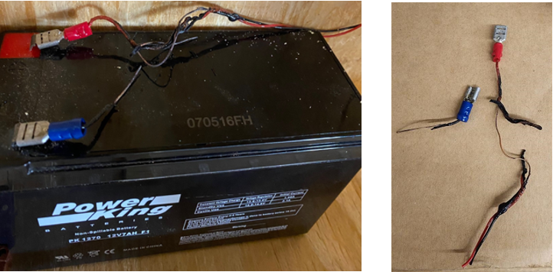

**Figure 71:** Melted wires

There were multiple problems in the mechanical design of the feeder. The specific design and dimensions of the SLS were not determined until after the feeder frame and hopper were built. To get the quarter-cup cutout of the SLS far enough into the food hopper compartments and eliminate any leak points or gaps, the drive shaft had to be installed within the base of the hopper. This made it more difficult to operate the SLS and support the drive shaft. The functioning of the product is largely dependent on the SLS, drive shaft, and food compartments fitting seamlessly together to prevent any blockages or friction points. The SLS should have been completely designed and assembled before building the food hopper. Then the proper volume calculations should have been executed to fit the base of the hopper to the SLS more precisely. This would have allowed the Drive shaft to be assembled below the hopper instead of inside it. Furthermore, plastic silicon sheets had to be used to get the food to funnel properly, instead of having the angled sidewalls perfectly fit to the edges of the SLS. This prevented dog food from accumulating on and around the drive shaft but changed the volume of the food-holding compartments.

The cutting tools used in the construction process were a skill saw, jigsaw, and hacksaw. A hand-held drill was used to drill any holes needed. It was difficult to make angled cuts with the cutting tools available. This included the assembly of the SLS and angled food hopper walls. A key lesson learned was that using the proper tools, such as a table saw for high-precision cuts would have resulted in a more well-rounded prototype. When the hole was drilled in the center of the SLS it was not made perfectly straight or sized. Once the drive shaft was pushed through the center of the SLS it looked straight, but when they were secured together with a screw, the SLS went off-kilter. This was because the hole in the SLS was not the precise in diameter or straightness as it should have been. This resulted in friction points and gaps causing food leakage. Having access to a drill press with the proper-sized drill bit would have eliminated this issue.

Another issue encountered during prototyping came from using wood to build the feeder. After eventually getting all of the components to fit together well enough for the feeder to function properly it was found that the wood dried out and changed shape. This resulted in friction points in the dispensing unit and bowl extension and retraction system. Alterations were made consistently to remove these friction areas as the wood slowly changed shape.

A major setback encountered during this design was the time needed to acquire some of the key components of the feeder. Numerous parts had to be substituted with less desirable components that did not function quite as intended. It was difficult to find affordable devices that could be obtained in a short timeframe. Instead of using wood to build the majority of the structure, food-safe injection molded materials would have been preferable. Additionally, the motorized wheels should be replaced by linear actuators to improve the functionality and reliability of the food bowl extension and retraction system. Replacing these devices with more suitable ones would be a major improvement to the feeder.

Future work:

Software needs to be rewritten to be fully object oriented including breaking the user settings into a separate Application Programming Interface (API) that can be used by both the LCD interface and an external application so that a smartphone app can be added to the product. The included libraries should be modified from the Arduino standard to fit their specific use. Following this, the exact requirements of the microprocessor could be quantified, and a lower-end and cheaper microcontroller could be specified. The addition of full error handling would also be beneficial.

The microcontroller and current contents of the breadboard should be consolidated into a single Printed Circuit Board (PCB) that can be manufactured at low cost and wired to the various components with standardized connectors.

Increasing the amount of available feeding schedules and giving user access to assigning multiple RFID tags to each side would expand the possible market from users with only two dogs to users with multiple dogs on different diets. For instance, households with more than two dogs but with one on a prescription diet or perhaps puppy food could also make use of the system.

The most notable failure point in the design is the RFID system. Just designing the RFID system for optimal functionality could be an entire project in itself. The easily obtainable RFIDs on the market are not adequate for the intended purposes of the project, suffering from some serious range issues. Designing a reliable active RFID system would go a long way in making this product more consumer friendly. On the same topic of user ease, an Internet of Things (IoT) app, even a rather simple Android app, would increase market value and consumer interest in the product markedly. This would allow the feeder to be even more hands-off, letting users control inputs and monitor their pets remotely. Optimally this would be offered alongside a video camera system in a “Deluxe” model.

The standby power draw of the prototype is far too high to achieve a 7 day operation on the included battery. The primary expected causes are the status LEDs included in the prototyping boards and the constant brightness LCD display. The brightness of the LCD display should be controlled by software and enable a low brightness mode during night or when running on battery power. The models of the LEDs included are not known, however using the 75 mW power draw of the SML-012UTT86 [41] as an estimate the 5 LEDs could account for as much as 27% of the standby power draw and should be removed. The 5-Volt linear regulator is also inefficient and should be replaced with a switching DC converter to further extend battery life.

As shown in the production model design of the automated dog feeder, using lessons learned during the prototyping phase, solutions were determined for the problems that were encountered. In a production model, all wooden components will be replaced with injection-molded parts. The proper calculations for food holding volumes and the properly angled walls of the food hopper ensure that the SLS fits perfectly to the hopper base, preventing food leaks and blockages, and that the food accumulates directly above the SLS cutout.

By using the proper tools and system devices, the system will have improved operability, usability, and efficiency. Furthermore, improving the food bowl extension and retraction system by implementing linear actuators not only improves the system, but also allows for decreasing the overall size of the dog feeder. Creating a proper production model would enable the design team to improve the automated dog feeder resulting in an adequate consumable product.

The finalized product serves as a functioning proof of concept. Each member of the design team played a key role in the success of the prototype’s electrical, software, and mechanical design. Collaborating as a group and using each member’s unique skillset to produce the automated dog feeder was a key takeaway, and perhaps the most valuable experience gained moving forward as future electrical engineers. Many lessons were learned while combining mechanical design with electrical components and coupling them to the software and programming system. Integrating these devices into one product proved to be a challenge but was ultimately successful. After determining solutions for issues in the prototype design, a more refined and operable product was designed. The automated dog feeder has the potential to provide a valuable service for dogs and dog owners. Further work on this design has the potential to fulfill this service.

**References:**

1. “Obesity in dogs: VCA Animal Hospital,” *Vca*. [Online]. Available: <https://vcahospitals.com/know-your-pet/obesity-in-dogs>. [Accessed: 25-Jan-2023].
2. [Online]. Available: <https://rawbistro.com/blogs/raw-bistro/food-aggression-in-dogs#:~:text=Try%20these%20seven%20steps%20to%20help%20put%20a,eat%20food%20from%20a%20bowl%20on%20the%20floor>. [Accessed: 25-Jan-2023].
3. “Pet ownership statistics [2022]: U.S pet population,” *Spots.com*, 07-Dec-2022. [Online]. Available: <https://spots.com/pet-ownership-statistics/>. [Accessed: 25-Jan-2023].
4. R. M. Ford and C. S. Coulston, “Chapter 3.5: Advanced Requirements Analysis,” in *Design for electrical and computer engineers: Theory, concepts, and Practice*, Boston, MA: McGraw-Hill, 2008, pp. 57–58.
5. R. M. Ford and C. S. Coulston, “Chapter 3.5: Advanced Requirements Analysis,” in *Design for electrical and computer engineers: Theory, concepts, and Practice*, Boston, MA: McGraw-Hill, 2008, pp. 58–59.
6. R. M. Ford and C. S. Coulston, “Chapter 3.5: Advanced Requirements Analysis,” in *Design for electrical and computer engineers: Theory, concepts, and Practice*, Boston, MA: McGraw-Hill, 2008, pp. 60–61.
7. *Rotary livestock feeder with gravity flow feed openings*. (n.d.). Retrieved February 17, 2023, from https://www.mysciencework.com/patent/show/rotary-livestock-feeder-gravity-flow-feed-openings-US20150359191A1
8. Google. (n.d.). *US5363805A - Automatic Pet Feeder*. Google Patents. Retrieved February 17, 2023, from https://patents.google.com/patent/US5363805A/en
9. Google. (n.d.). *US4181037A - lazy Susan Assembly having an adjustable alignment mechanism*. Google Patents. Retrieved February 17, 2023, from https://patents.google.com/patent/US4181037
10. R. M. Ford and C. S. Coulston, “Chapter 3.5: Advanced Requirements Analysis,” in *Design for electrical and computer engineers: Theory, concepts, and Practice*, Boston, MA: McGraw-Hill, 2008, pp. 57–58.
11. G. Reviews, “What is the difference between kidney-shaped and Pie Cut lazy susans?,” *Woodworker Express*. [Online]. Available: https://www.woodworkerexpress.com/kidney-shaped-vs-pie-cut-lazy-susans/. [Accessed: 04-Mar-2023].
12. “Arf Pets Automatic Dog & Cat Feeder, white, 18-Cup,” *ARF PETS Automatic Dog & Cat Feeder, White, 18-cup - Chewy.com*. [Online].
13. “Arf Pets Automatic Dog & Cat Feeder, white, 18-Cup,” *ARF PETS Automatic Dog & Cat Feeder, White, 18-cup - Chewy.com*. [Online]. Available: https://www.chewy.com/arf-pets-automatic-dog-catfeeder/dp/139369?utm_id=401602544&msclkid=5e8d17609b1b1c69c335748f6fd17c0b&utm_source=bing&utm_medium=cpc&utm_campaign=Shopping_NC_Dog_HG_Technology&utm_term=4584826056283813&utm_content=Automation%2BProducts-Dog%2BFeeders%2BWaterers. [Accessed: 04-Mar-2023].
14. “(PDF) solar charger sizing - researchgate.” [Online]. Available: https://www.researchgate.net/publication/282948797_Solar_Charger_Sizing. [Accessed: 04-Mar-2023].
15. “Norpro ‘the original’ grape spiral - amazon.com.” [Online]. Available: https://www.amazon.com/Norpro-The-Original-Grape-Spiral/dp/B000LNU006. [Accessed: 04-Mar-2023].
16. “PaddleWheelImage.” [Online]. Available: https://www.manomano.co.uk/p/relaxdays-dual-muesli-dispenser-with-paddle-wheel-cereal-candy-container-hwd-41x325x19-cm-black-49830208. [Accessed: 04-Mar-2023].
17. “Newagepet vinyl flap door - medium,” *The Home Depot Canada*. [Online]. Available: https://www.homedepot.ca/product/newagepet-vinyl-flap-door-medium/1000723600. [Accessed: 04-Mar-2023].
18. “Black Scissors Vector Image,” *Black scissors | Public domain vectors*. [Online]. Available: https://publicdomainvectors.org/en/free-clipart/Black-scissors/72397.html. [Accessed: 04-Mar-2023].
19. E. Ahmed, “Free CAD designs, Files & 3D models: The grabcad community library,” *Free CAD Designs, Files & 3D Models | The GrabCAD Community Library*. [Online]. Available: https://grabcad.com/library/servo-motor-35-kg-cm-aluminum-mid-shell-ft5835m-1. [Accessed: 04-Mar-2023].
20. I. Milan, “Free CAD designs, Files & 3D models: The grabcad community library,” *Free CAD Designs, Files & 3D Models | The GrabCAD Community Library*. [Online]. Available: https://grabcad.com/library/funnel-12. [Accessed: 04-Mar-2023].
21. W. Rogers, “Free CAD designs, Files & 3D models: The grabcad community library,” *Free CAD Designs, Files & 3D Models | The GrabCAD Community Library*. [Online]. Available: https://grabcad.com/library/zemic-load-cell-1. [Accessed: 04-Mar-2023].
22. J. Heulin, “Free CAD designs, Files & 3D models: The grabcad community library,” *Free CAD Designs, Files & 3D Models | The GrabCAD Community Library*. [Online]. Available: https://grabcad.com/library/ball-bearing-telescopic-slide-1. [Accessed: 04-Mar-2023].
23. S. Reddioui, “Free CAD designs, Files & 3D models: The grabcad community library,” *Free CAD Designs, Files & 3D Models | The GrabCAD Community Library*. [Online]. Available: https://grabcad.com/library/motor-wheel-for-robot-1#! [Accessed: 04-Mar-2023].
24. A. Aelevanthara, “Free CAD designs, Files & 3D models: The grabcad community library,” *Free CAD Designs, Files & 3D Models | The GrabCAD Community Library*. [Online]. Available: https://grabcad.com/library/arduino-mega-2560--1#! [Accessed: 04-Mar-2023].
25. M. Ewing, “Free CAD designs, Files & 3D models: The grabcad community library,” *Free CAD Designs, Files & 3D Models | The GrabCAD Community Library*. [Online]. Available: https://grabcad.com/library/tactile-switch-short-1. [Accessed: 07-Mar-2023].
26. Zawisza, “Free CAD designs, Files & 3D models: The grabcad community library,” *Free CAD Designs, Files & 3D Models | The GrabCAD Community Library*. [Online]. Available: https://grabcad.com/library/lcd1602-4. [Accessed: 07-Mar-2023].
27. “23.16US $ 20% off: 1PCS 1mod 1 Modulus Gear Rack Steel 20*20*500mm + 1PCS 1mod 45teeth pinion bore Hole 6/8/10/12mm steel #45 Gear Metal Gear: | - aliexpress,” aliexpress.com. [Online]. Available: https://www.aliexpress.us/item/3256804560109917.html?spm=a2g0o.productlist.main.63.288c5421VvQaHE&algo_pvid=d0dbbc28-2105-404b-892f-05f22447d420&algo_exp_id=d0dbbc28-2105-404b-892f-05f22447d420-31&pdp_npi=3%40dis%21USD%2128.95%2123.45%21%21%21%21%21%40212243c016815842804272263d06cc%2112000030323041076%21sea%21US%210&curPageLogUid=CH0LEkA9FJNt. [Accessed: 17-Apr-2023].
28. “38.65US $ 35% off: 700N electric push rod stretchable 250mm 300mm 350mm 400mm stroke linear actuator DC 12V linear motor: | - aliexpress,” aliexpress.com. [Online]. Available: https://www.aliexpress.us/item/3256804920486619.html?spm=a2g0o.productlist.main.1.7e911b64BGs7vE&algo_pvid=eeb37c8d-1626-41c6-804a-2a02d20c591b&algo_exp_id=eeb37c8d-1626-41c6-804a-2a02d20c591b-0&pdp_npi=3%40dis%21USD%2164.52%2141.94%21%21%21%21%21%40212279a216815871452048220d0704%2112000031683379186%21sea%21US%210&curPageLogUid=RxkRf4bfvHD5. [Accessed: 17-Apr-2023].
29. “What drives the cost of custom injection molding?,” Pioneer Plastics, 15-Feb-2023. [Online]. Available: https://www.pioneerplastics.com/blog/what-drives-the-cost-of-custom-injection-molding/. [Accessed: 17-Apr-2023].
30. “Free CAD designs, Files & 3D models: The grabcad community library,” Free CAD Designs, Files & 3D Models | The GrabCAD Community Library. [Online]. Available: https://grabcad.com/library/eco-worthy-linear-actuator-eco-250-1. [Accessed: 17-Apr-2023].
31. “2.45 GHz active RFID tags: Beaconing tags - gao RFID inc..,” *GAO RFID*. [Online]. Available: https://gaorfid.com/devices/rfid-tags-by-frequency/active-2-45-ghz-rfid-tags/. [Accessed: 23-Apr-2023].
32. “RFID long range antenna,” *Wholesale rfid long range antenna for Access Control Using Your Smartphone – Alibaba.com*. [Online]. Available: https://www.alibaba.com/showroom/rfid-long-range-antenna.html. [Accessed: 23-Apr-2023].
33. D. A. Neamen, *Microelectronics: Circuit Analysis and Design*, Fourth. New York City, New York: Raghothaman Srinivasan, 2010.
34. STMicroelectronics. "L78 Series - Positive voltage regulators." Mouser Electronics. Accessed: Apr. 27, 2023. [Online]. Available: <https://www.mouser.com/datasheet/2/389/l78-1849632.pdf>.
35. STMicroelectronics. "L78S Series - Positive voltage regulators." Mouser Electronics. Accessed: Apr. 27, 2023. [Online]. Available: <https://www.mouser.com/datasheet/2/389/l78s-1849452.pdf>.
36. ON Semiconductor. "TIP120, TIP121, TIP122 (NPN); TIP125, TIP126, TIP127 (PNP) Complementary Silicon Power Transistors." Mouser Electronics. Accessed: Apr. 27, 2023. [Online]. Available: <https://www.mouser.com/datasheet/2/308/1/TIP120_D-2320196.pdf>.
37. Vishay Semiconductors. "1N5352B Series, - Zener Voltage Regulators." Mouser Electronics. Accessed: Apr. 27, 2023. [Online]. Available: <https://www.mouser.com/datasheet/2/849/1n5345b-2577211.pdf>.
38. TMRh20. "TMRpcm: Arduino library for asynchronous playback of PCM/WAV files direct from SD card." GitHub, 2022. [Online]. Available: <https://github.com/TMRh20/TMRpcm>.
39. HX711 datasheet, Digi-Key Electronics. [Online]. Available: <https://www.digikey.com/htmldatasheets/production/1836471/0/0/1/hx711.html?utm_adgroup=Integrated%20Circuits&utm_source=google&utm_medium=cpc&utm_campaign=Dynamic%20Search_EN_RLSA&utm_term=&utm_content=Integrated%20Circuits&gclid=CjwKCAjwo7iiBhAEEiwAsIxQEVw4RKfH93Gp-0PruieNH1MOsGa1sSdHJcPx_9l5N4AyNNs-piHrIBoCF4AQAvD_BwE>, Apr. 30, 2023.
40. "Arduino Libraries," Arduino Reference. [Online]. Available:

[https://www.arduino.cc/reference/en/libraries/?_gl=1*1tvgyb7*_ga*MjA5MjQzNDc5NS4xNjgxNDE1MjA5*_ga_NEXN8H46L5*MTY4Mjg4MjY3My4xOC4xLjE2ODI4ODI2NzUuMC4wLjA](https://www.arduino.cc/reference/en/libraries/?_gl=1*1tvgyb7*_ga*MjA5MjQzNDc5NS4xNjgxNDE1MjA5*_ga_NEXN8H46L5*MTY4Mjg4MjY3My4xOC4xLjE2ODI4ODI2NzUuMC4wLjA). [Accessed: Apr. 30, 2023]

1. SML-012UTT86-E datasheet, ROHM Semiconductor. [Online]. Available: <https://fscdn.rohm.com/en/products/databook/datasheet/opto/led/chip_mono/sml-012utt86-e.pdf>. [Accessed: Apr. 30, 2023].
2. Elechouse. (2019, June 12). PN532. GitHub. <https://github.com/elechouse/PN532>
3. U.S. Government Publishing Office, "Electronic Code of Federal Regulations: Title 16 - Commercial Practices, Chapter II - Consumer Product Safety Commission," 2021. [Online]. Available: <https://www.ecfr.gov/cgi-bin/text-idx?SID=15d9b0a45b364a30a8f6e5c6f5d6b482&mc=true&tpl=/ecfrbrowse/Title16/16chapterII.tpl>. [Accessed: May 2, 2023].

**Appendix A: Pinout Diagram**

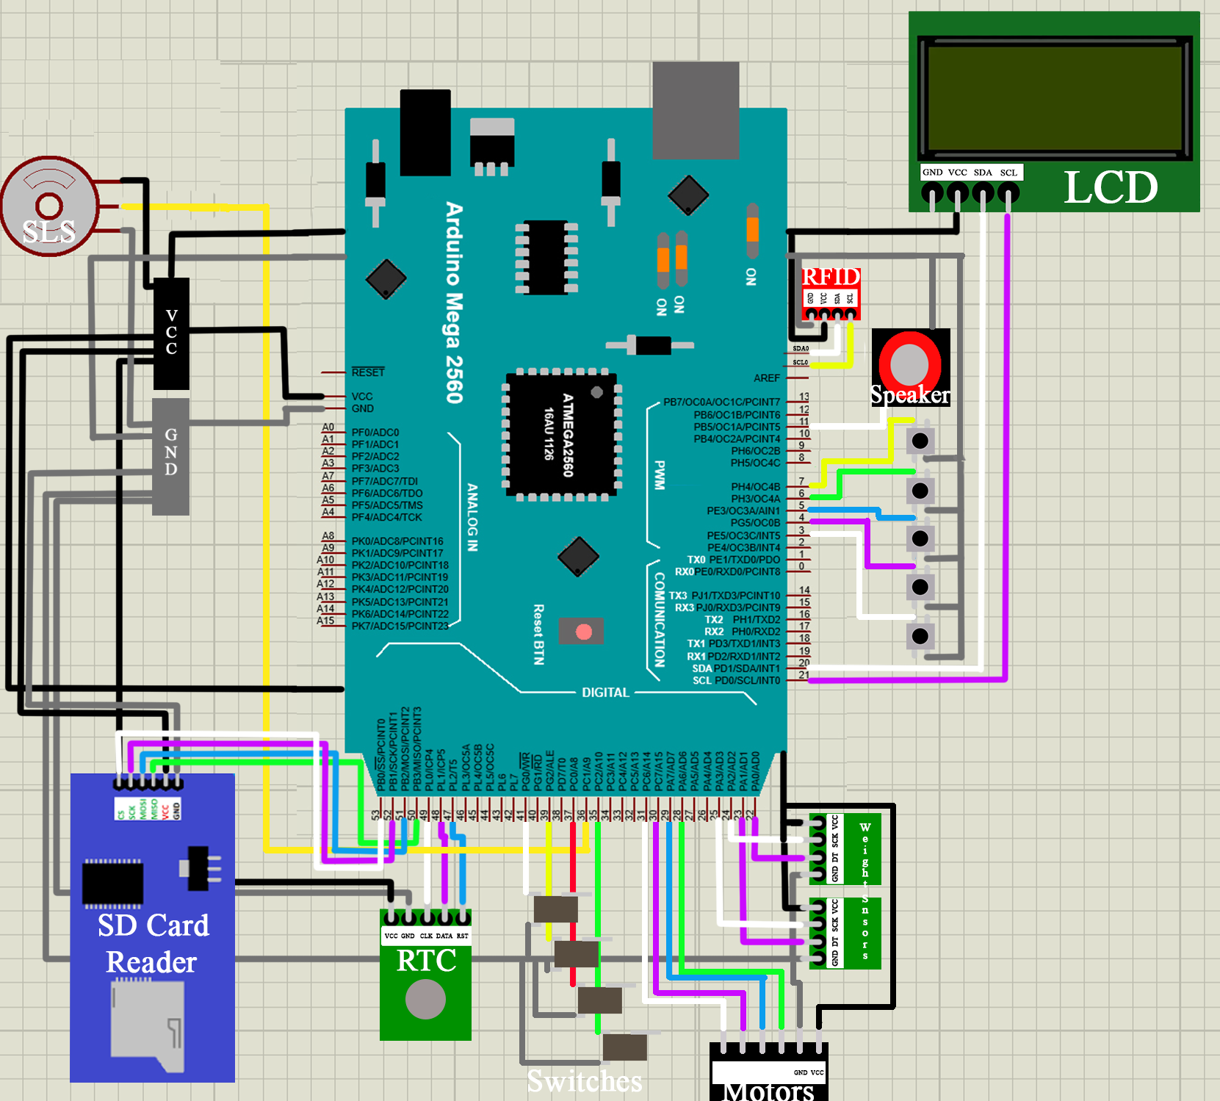

**Appendix B: User’s Manual**

1. **- General Information**

**1.1 – Features**

1. Feeds twice a day according to users set time(s)
2. Two 1.8-gallon food storage containers
3. Safe and usable for multi-dog applications
4. Calls dog with unique sounds
5. Unique sounds may be inserted by the user.
6. Able to feed any size of dog for a minimum of 1 week.
7. Keeps food sealed and fresh.
8. Bowl drawers controlled by collar fitted RFID tags.

**1.2 – Symbol Key**

** Enter –** Selects current setting that cursor is pointed at.

** Back –** Goes back to previous menu.

** Up –** Moves cursor up one selection.

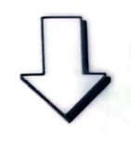 **Down –** Moves cursor down one selection.

** Menu –** Returns to main menu.

**1.3 – Dog Weight Relative Feeding Amounts**

The SLS dispenses food from the compartments in ¼ cup increments. The average recommended feeding ratio for dogs is shown below.

|  |  |
| --- | --- |
| Dog Weight (Pounds) | Dry Food Amount (Cups) |
| 2 – 12 | .25 – 1 |
| 13 – 19 | 1 – 1.25 |
| 20 – 34 | 1.25 – 2 |
| 35 – 49 | 2 – 2.5 |
| 50 – 74 | 2.5 – 3.25 |
| 75 – 99 | 3.25 – 4.25 |
| 100 + | 4.25 + .25 for every 10 lbs over 100 |

The product is intended to feed a 100+ lb dog 4 cups a day for a week.

**2.0 – User Setup**

**2.1 – Getting Started**

To begin using this system to feed your dog, you will first need to fit the provided RFID tags to the appropriate dog for the side you want them to feed from. This is most easily done by attaching the tag directly to the dogs collar. Fill the corresponding food compartment that matches the name given on the tag. Once this is accomplished you can begin selecting feeding cycles, which is further elaborated on in section 2.3.

**2.3 – How to use your feeder to aid in training**

The process of acclimating your dogs to the automated feeding system will require the owner to be present for several feeding cycles. The dogs will need to develop a Pavlovian response to the sounds the system outputs when scheduled feeding has begun. Depending on the intelligence level of your dog. Smarter breeds may pick it up fast, while the less intelligent breeds may struggle to understand the functionality of the feeder at all.

**2.3 – How to add sound files**

The system comes with several sample sounds preinstalled, but you can also upload your own unique sounds to call your dog. This is done by loading your own .wav files to the supplied SD card accessible from the front compartment. Free audio manipulation programs such as Microsoft Audacity can be used to record your own voice or any sound you wish to use. These files must be 16000 HZ sample rate 8-bit wav files with no longer than an 20-character name (characters include spaces!) With a little googling, this is fairly easy for anyone with a little tech savvy to do. For our less tech-oriented owners they can always rely on the sample library. There are some major issues that can occur if this is done incorrectly, this is expanded upon in section 3.1.

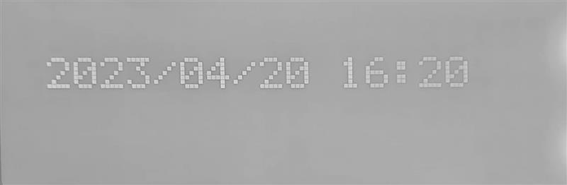**2.4 – How to set clock and feeding times**

While in standby the current time is displayed in Year/Month/Day Hours : Minutes with 24 hour clock format so that feeding times cannot be confused.

The menu can be accessed any time the feeder is not dispensing food by pressing the  “menu” button on the button module. You can exit the menu by pressing the  “back” button.

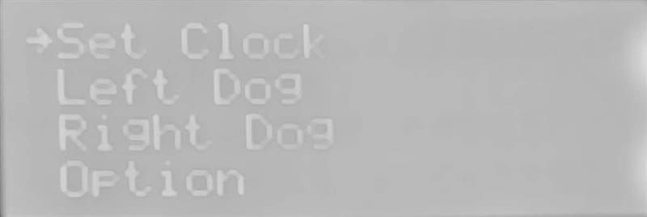Set the clock by navigating to “Set Clock” using the  “up” and  “down” buttons to move the selection arrow and pressing  “enter”. The clock will display. Use the  “up” and  “down” buttons to increase or decrease the year and press  “enter” to set. The month, day, hour, and minute then be set with the same process. After selecting the minute press  “enter” to set the clock and return to the main menu. You can return to the previous setting by pressing  “back” and exit the clock without setting by pressing  “back” until on the menu.

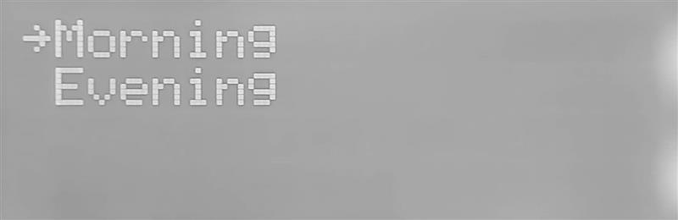To set feeding times enter the main menu and select either the “Left Dog” or “Right Dog” selections using  “up” and  “down” and pressing  “enter”. You will be prompted to select either “morning” or “evening” feeding times  “up” and  “down” and pressing  “enter”. *Note: the use of “morning” and “evening” is only to differentiate the two available settings any feeding can be scheduled at any time of day. However, it is recommended no two feeding times are set within five minutes of each other.*

After selecting feeding the currently set feeding schedule will display use  “up” and  “down” to set the feeding volume [1] from 0.25 to 4.00 cups in increments of 0.25 cups and press**** “enter” to move to the time. Set the time [2] in 24 hour and minutes you would like your dog to be fed. Then set whether you would like to “always” feed the entire selected amount, “fill” the bowl to the selected amount, or “wait” until the food in the bowl is entirely gone to refill[3]. Weight Sensors under each bowl . Then select from 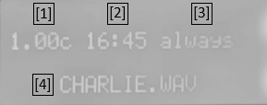any of the preloaded call sounds or any sounds you added yourself [4] (As long as it doesn’t break the requirements specified in section 3.1). All 4 feeding schedules are set following the same directions.

The final setting under “option” is to allow simultaneous feeding of both dogs, select “yes” to allow both dogs to eat at the same time or “no” to close the bowls when both dogs are are present.

**3.0 – WARNINGS**

**3.1 – Issues with sound files**

If the conditions specified within section 2.2 are not met, several issues ranging from minor to serious can arise. If a sample rate of 16kHZ is not selected, the sound will either be too slow, too fast, or will not be audible at all. If the file is not an 8-bit wav file, it will not play. If the 20-character limit is breached then nothing will run, system will be bricked until reset.

**3.2 – Interface Timeout**

If the interface is left to idle for 5 minutes, it will timeout. This will cause any changes made to not save.

**Appendix C: Main Code (Mention Appendix B as reference somewhere in the report text)**